Rental Monitoring

User’s Guide

**Table of Contents**

Table of Contents………………………………………………………………………………………………….…………………...1

Glossary of Terms……………………………………………………………………………………………………………………...2

Logging into the Rental Monitoring system………………………………………………………………….……………..3

Logging out of the Rental Monitoring system……………………………………………………………….…………….4

Deliveries…………………………………………………………………………………………………………………………………..5

Parts…………………………………………………………………………………………………………………………………………11

Accessories………………………………………………………………………………………………………………………………16

Computers……………………………………………………………………………………………………………………………….20

Clients……………………………………………………………………………………………………………………………………..26

Generate Rental Forms……………………………………………………………………………………………………………30

Pull-outs………………………………………………………………………………………………………………………………….32

Various Summaries about the Inventory………………………………………………………………………………….41

User Management……………………………………………………………………………………………………………………46

**Glossary of Terms**

The Rental Monitoring system was made to make managing the Rental inventory more convenient and to centralize the Rental database for easier access and reference. It was also made to make and keep track of Deliveries to Clients.

Objectives of the system:

* Make managing the Rental inventory easier
* Centralize the Rental inventory for everyone’s reference
* Manage and keep track of Deliveries to Clients

Terms

Rental Monitoring system: The application used to manage the inventory of Rental Units.

Rental Units: The Computers and their accessories that are rented to clients.

Computers: Desktop computers, laptops, or workstations.

Clients: The customers who wishes to avail of a Rental Unit.

Parts: The electronic components of a Computer that are necessary to make them operational.

Accessories: The peripheral devices that contribute to the convenience of using Computers.

Deliveries: A formal request made by a Client to rent certain Rental Units for a period of time.

Rental Requirement form: A form stating the list of Rental Units that are to be delivered to a Client, at a given place, on a given date, overseen by a given Account Manager.

Pull-out form: A form stating the list of Rental Units that are to be returned by a Client to the inventory of Rental Units. Similar to the Rental Requirement form in appearance.

User: A person using the Rental Monitoring system.

Role: A set of privileges given to a certain User regarding the management of the inventory through the Rental Monitoring system.

**Logging into the Rental Monitoring system**

**Step 1**: Navigate to the website

**Step 2**: Enter your login credentials here and press the Login button. In case your login attempt fails even though your login credentials are correct, simply try again.

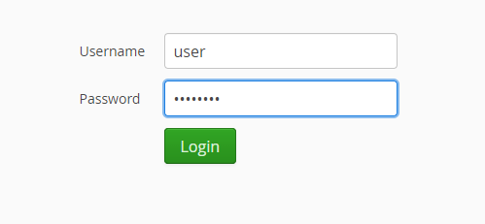

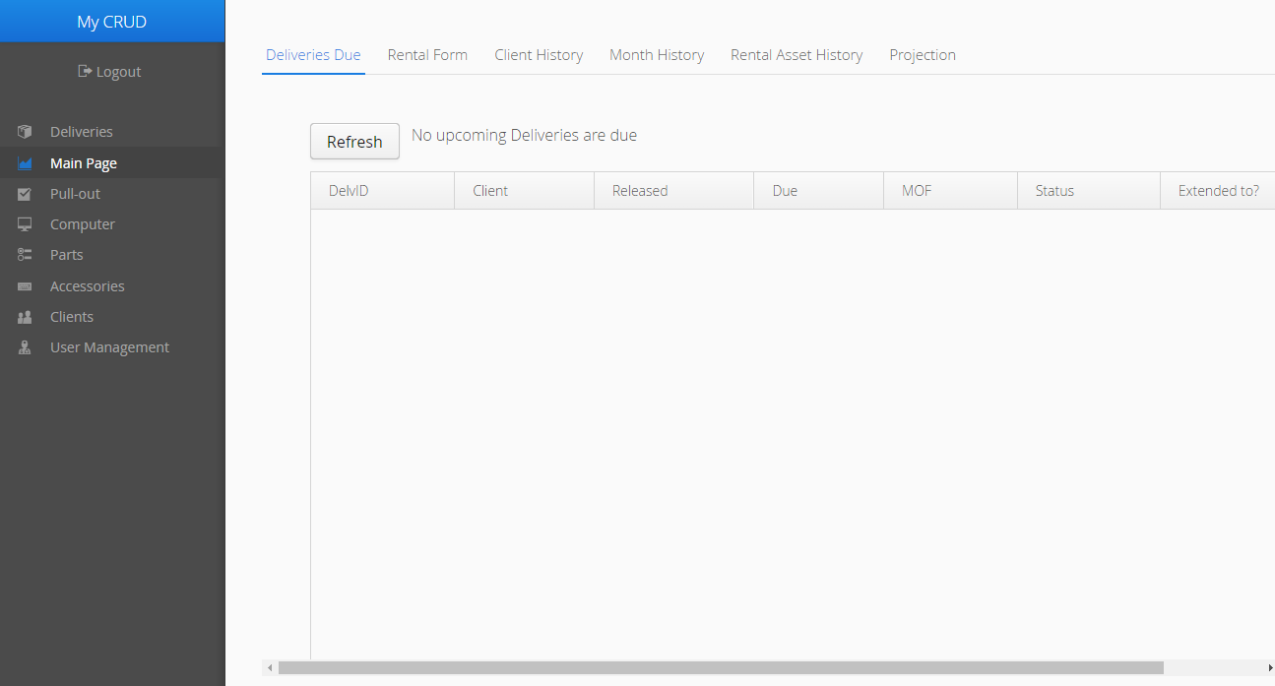The Main Page screen should appear in your browser. Content will vary according to your Role in the system.

**Logging out of the Rental Monitoring system**

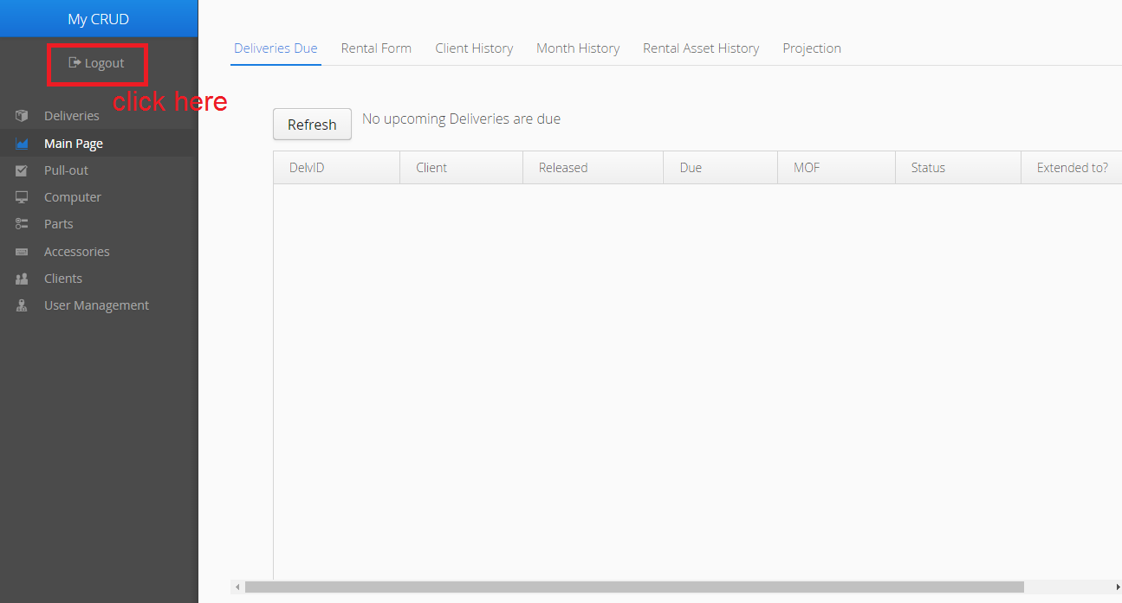**Step 1**: From any page in the system, press the Logout button in the Menu bar

If the logout is successful, your browser should display the Login screen.

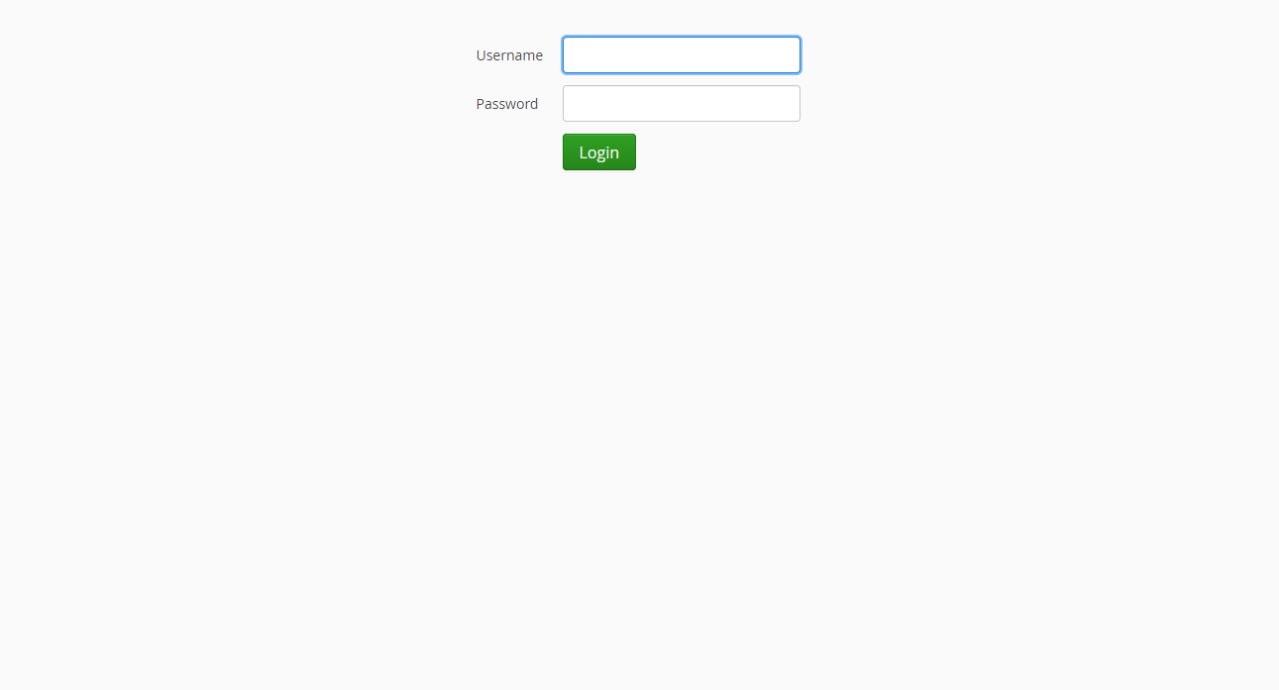

**Deliveries**

**View the list of all Deliveries**

A Delivery is placed by a Client for the rental of Computers and other devices.

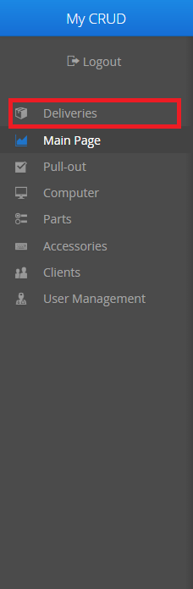**Step 1**: Click on the Deliveries tab in the Menu bar

**Step 2**: The list of Deliveries should already be filled. If you want to refresh the list, click on the View Deliveries button.

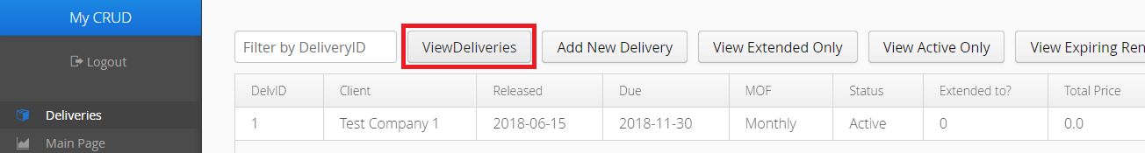

**Step 2a**: If you want to filter Deliveries based on Delivery ID, fill in the search bar, and the list will automatically adjust to your search query as you type. You may also enter multiple IDs, but they must be separated by a forward slash (/).

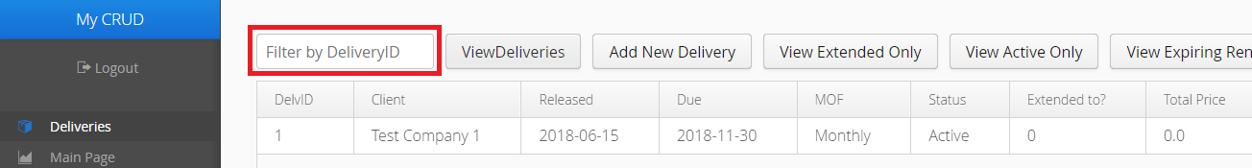

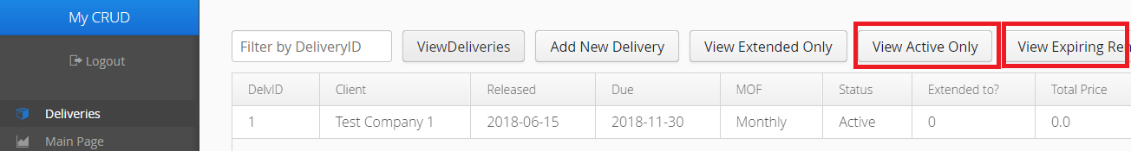**Step 2b**: If you want to filter Deliveries based on their availability, or find any Deliveries that are about to terminate in a week, click the View Active Only or the View Expiring Rentals buttons, respectively.

**Step 2c**: If you want to filter only extended Deliveries, click the View Extended Only button.

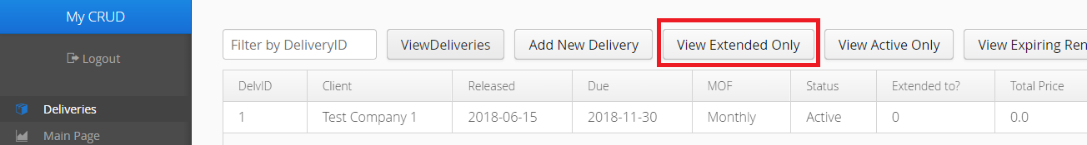

**Encoding and Editing Deliveries**

In order to encode and edit Deliveries, you must have the Reports role or higher.

**Step 1**: To create a Delivery, click the Add New Delivery button. Your browser should show an empty form.

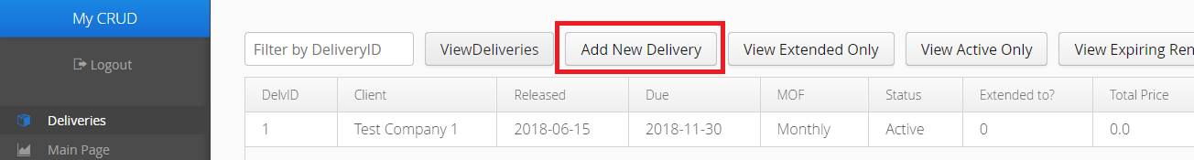

**Step 2**: Fill in the fields where necessary. If you cannot fill in the fields with red asterisks, the form cannot be saved to the server.

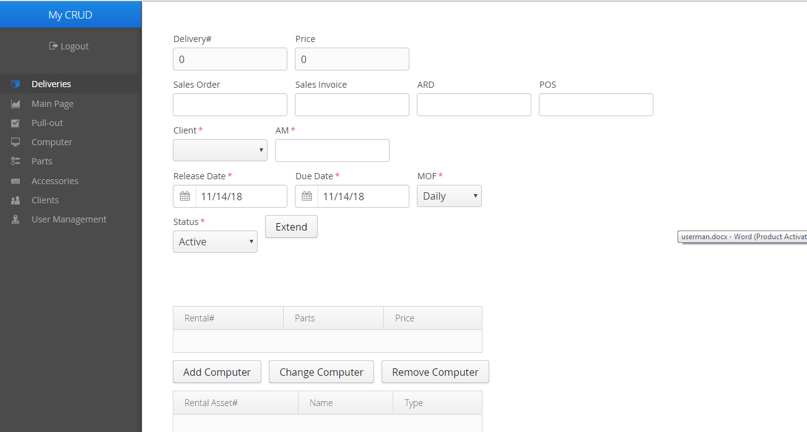

**Step 2a**: When selecting Rental Units in Adding or Editing (Rental) Units/Accessories, you can filter them according to the Rental Unit number.

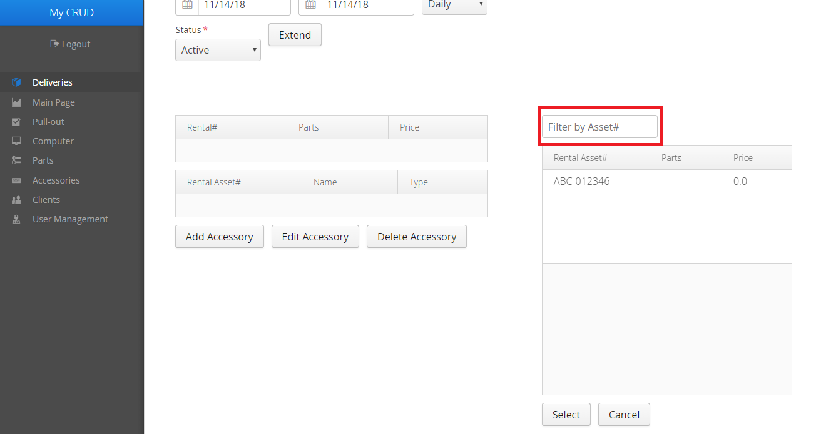

**Step 2b**: To remove a Rental Unit, select it in the list of Rental Units, then click the Delete Unit/Accessory button.

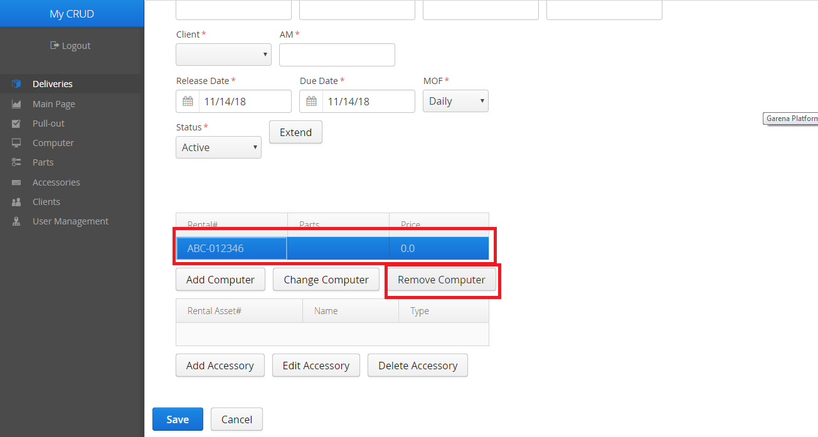

Note that this will not actually remove it from the inventory, only from the Delivery. This is NOT the same as Pulling the Unit out, please refer to the Pull-out manual for the proper process of Pulling Units out.

**Step 3**: When you are finished with the Delivery form, click on the Save button at the bottom of the form. Click on Cancel if you would like to discard the form instead.

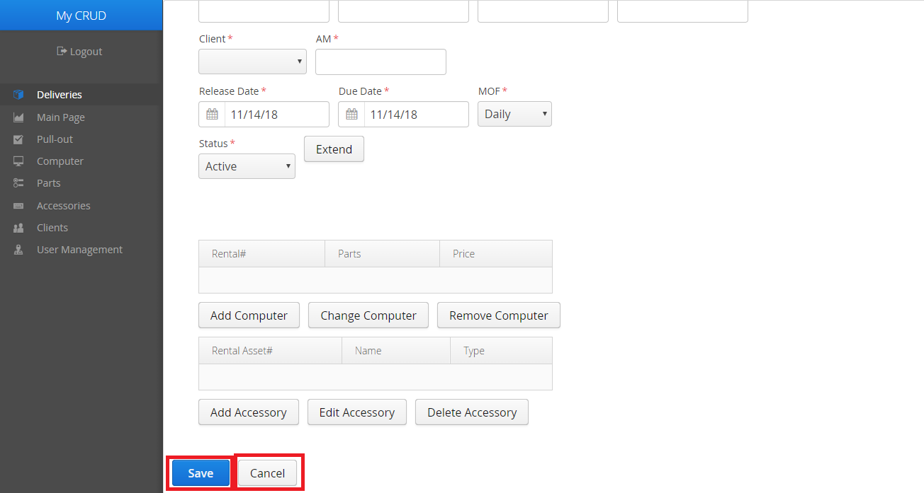

The process of editing Deliveries is the same.

**Step 1**: From the list of Deliveries, click on the Delivery you would like to edit. The form that will appear should be filled out with the chosen Delivery’s data.

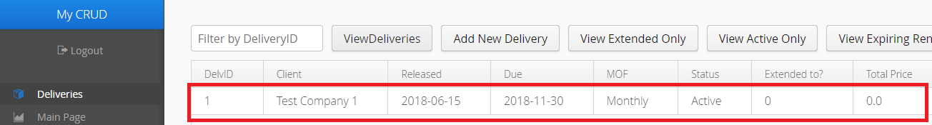

**Step 2**: Follow the instructions for creating a new Delivery from step 2.

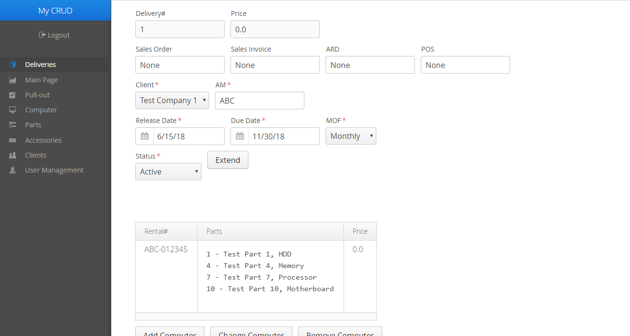

**Parts**

**View the list of all Parts**

These are Computer Parts that make up a Computer.

**Step 1**: Click on the Parts tab in the Menu bar.

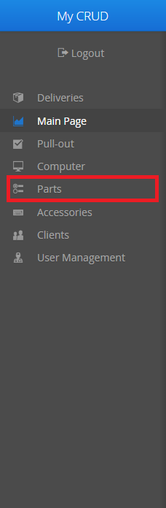

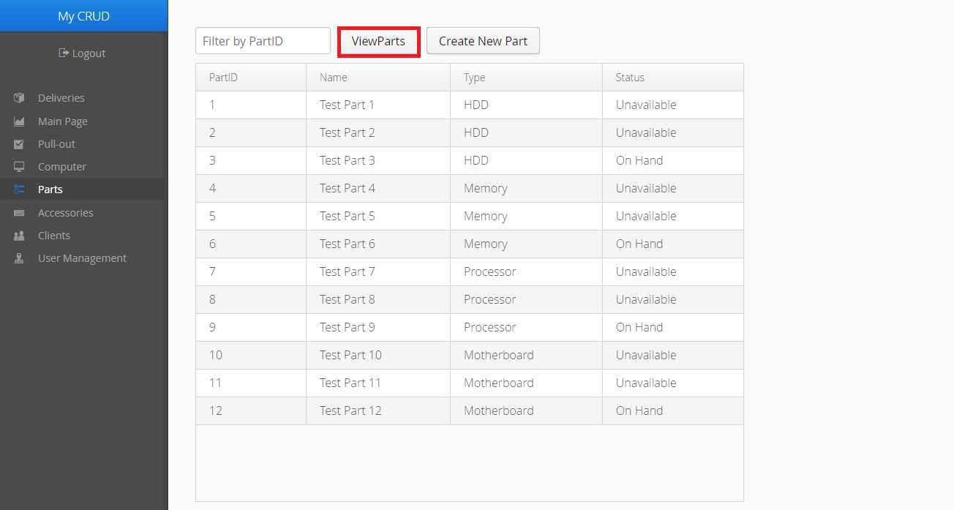**Step 2**: The List of Parts should already be filled out. If you would like to refresh the list, click the View Parts button.

**Encoding and Editing Parts**

You must be an Admin or higher in order to encode and edit Parts.

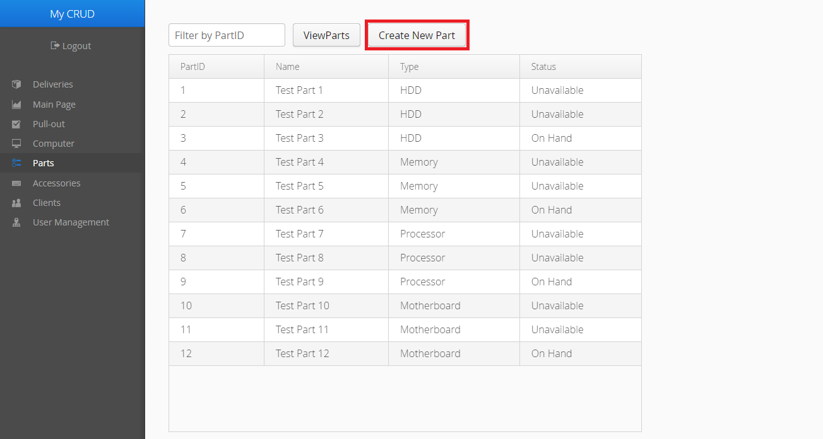**Step 1**: To create a Part, click on the Add New Part button. An empty form should appear on the right-hand side of the screen.

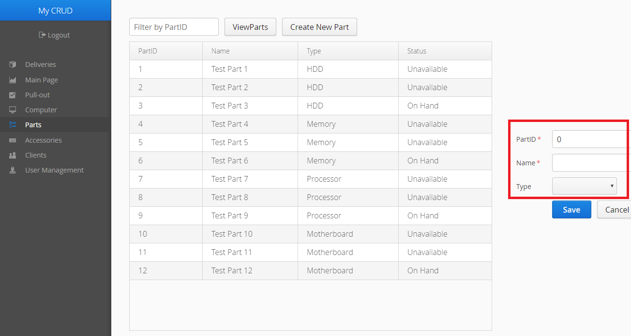**Step 2**: Fill in the fields where necessary. If you cannot fill in the fields with red asterisks, the form cannot be saved to the server. If the form appears to exceed your screen, you can use the scroll bar at the bottom of the page to view more of the form.

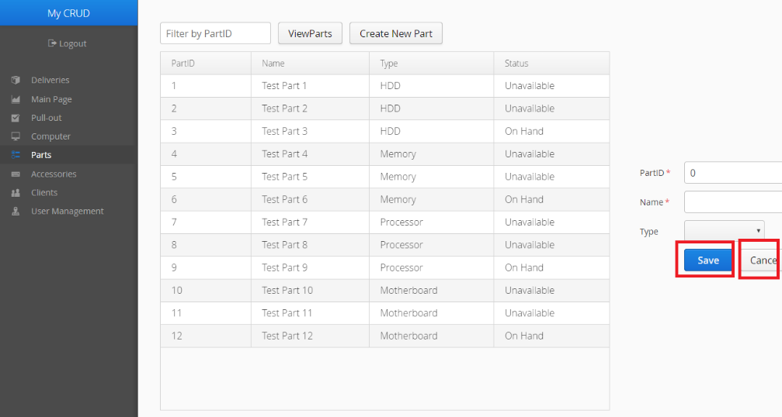**Step 3**: Click the Save button when you are finished. Click Cancel if you would like to discard the form instead.

The process of editing Parts is the same.

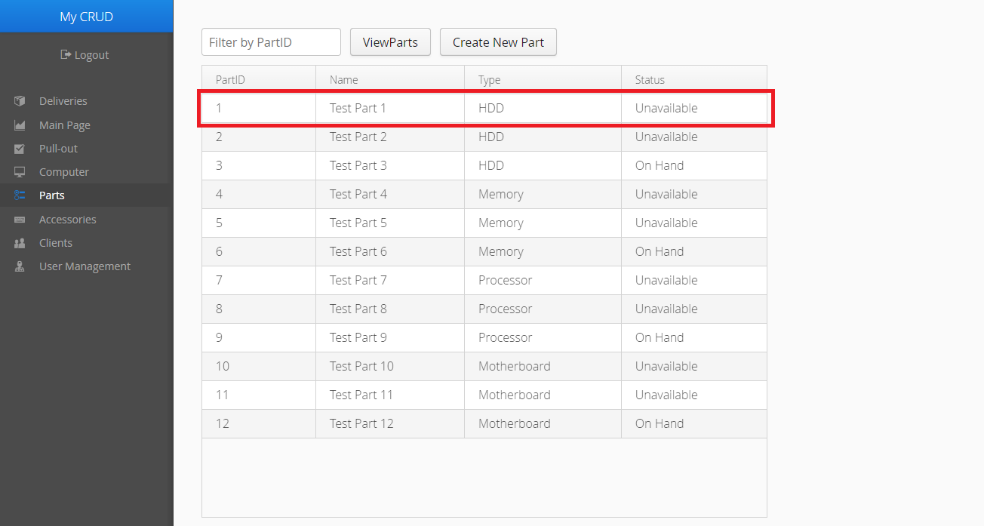**Step 1**: From the list of Parts, click on the Part you would like to edit. The form that will appear should be filled out with the chosen Part’s data.

**Step 2**: Follow the instructions above from step 2.

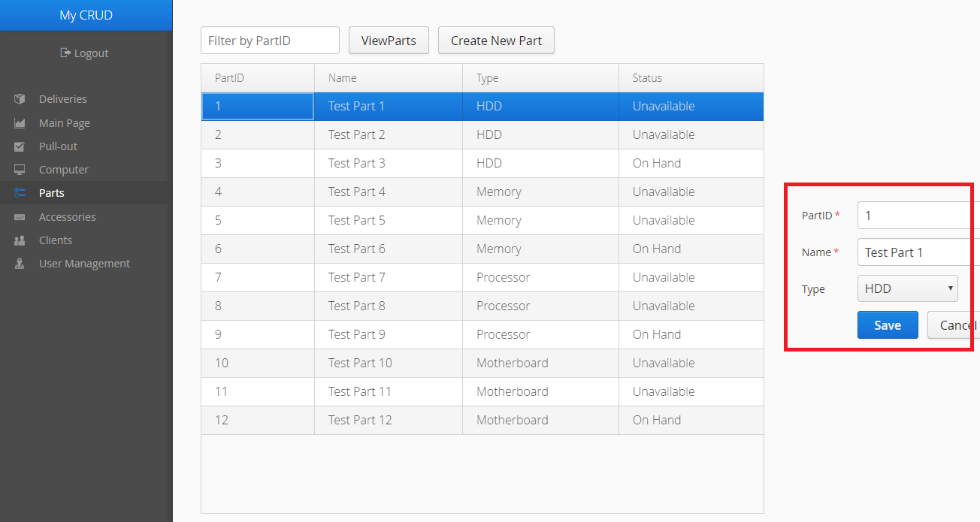

**Accessories**

**View the list of all Accessories**

Accessories are the miscellaneous devices used with Rental Units. Accessories are also Rental Units as well, and have their own Rental Unit number.

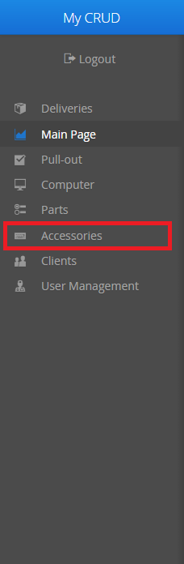**Step 1**: Click on the Accessories tab in the Menu bar.

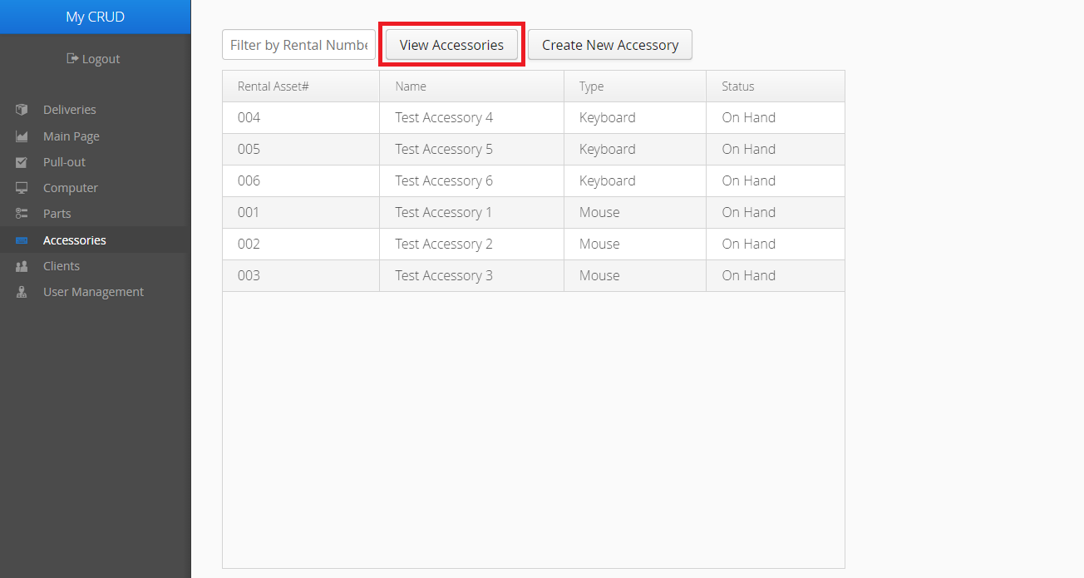**Step 2**: The List of Accessories should already be filled out. If you would like to refresh the list, click the View Accessories button.

**Encoding and Editing Accessories**

You must be an Admin or higher in order to encode and edit Accessories.

**Step 1**: To create an Accessory, click on the Create New Accessory button. An empty form should appear on the right-hand side of the screen.

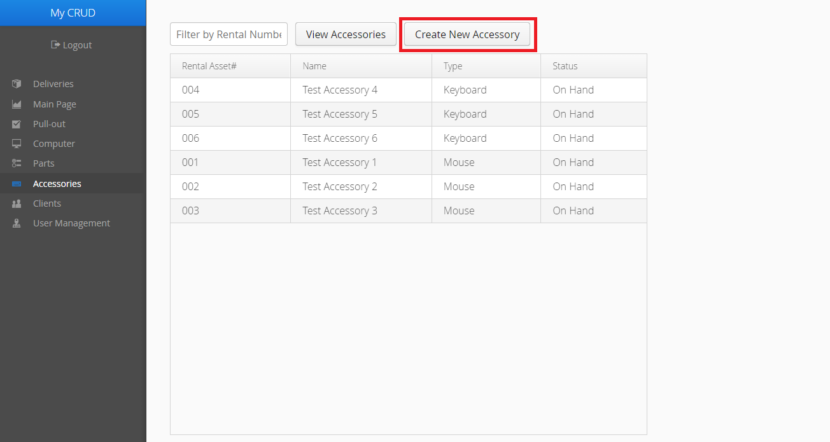

**Step 2**: Fill in the fields where necessary. If you cannot fill in the fields with red asterisks, the form cannot be saved to the server. If the form appears to exceed your screen, you can use the scroll bar at the bottom of the page to view more of the form.

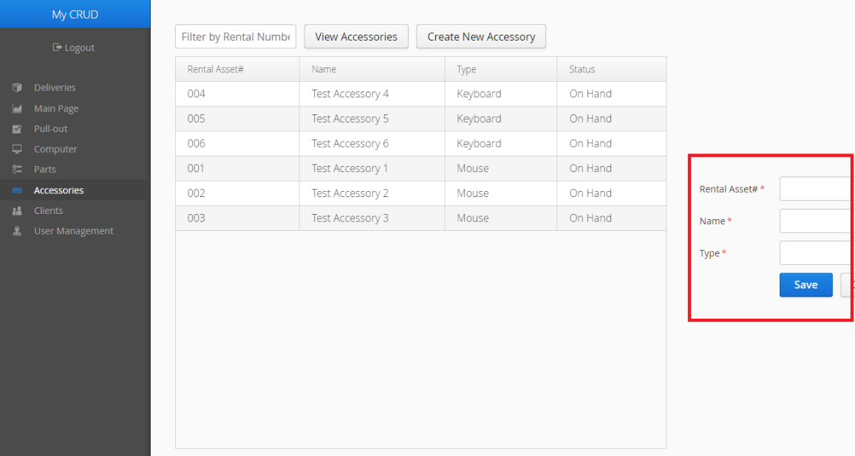**Step 3:** Click the Save button when you are finished. Click Cancel if you would like to discard the form instead.

The process of editing Accessories is the same.

**Step 1**: From the list of Accessories, click on the Accessory you would like to edit. The form that will appear should be filled out with the chosen Accessory’s data.

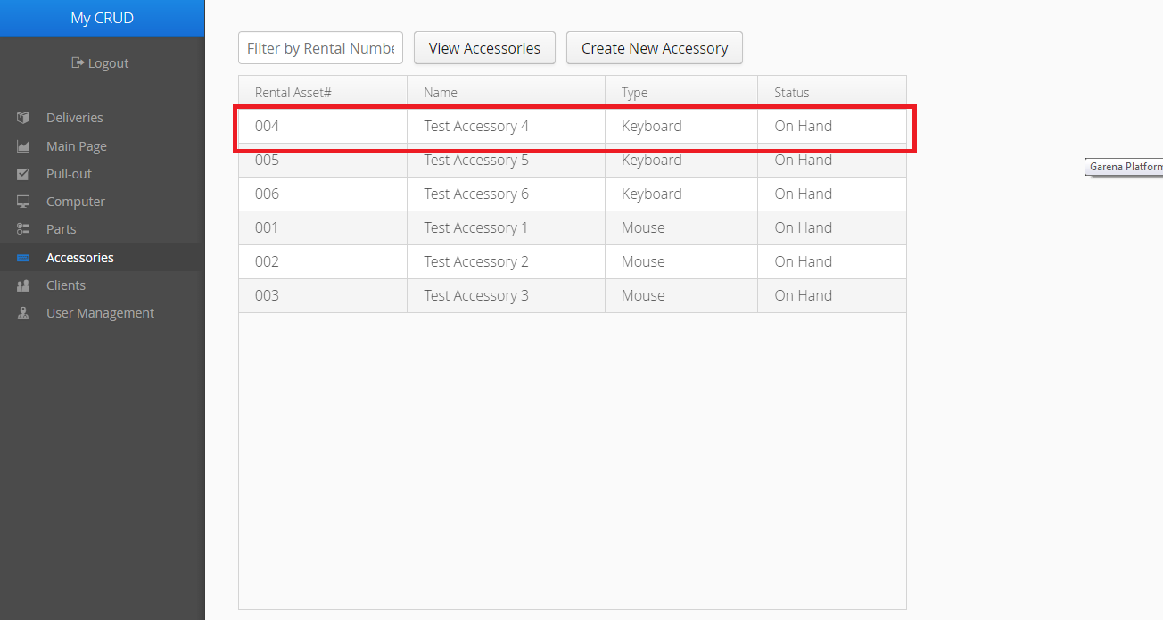

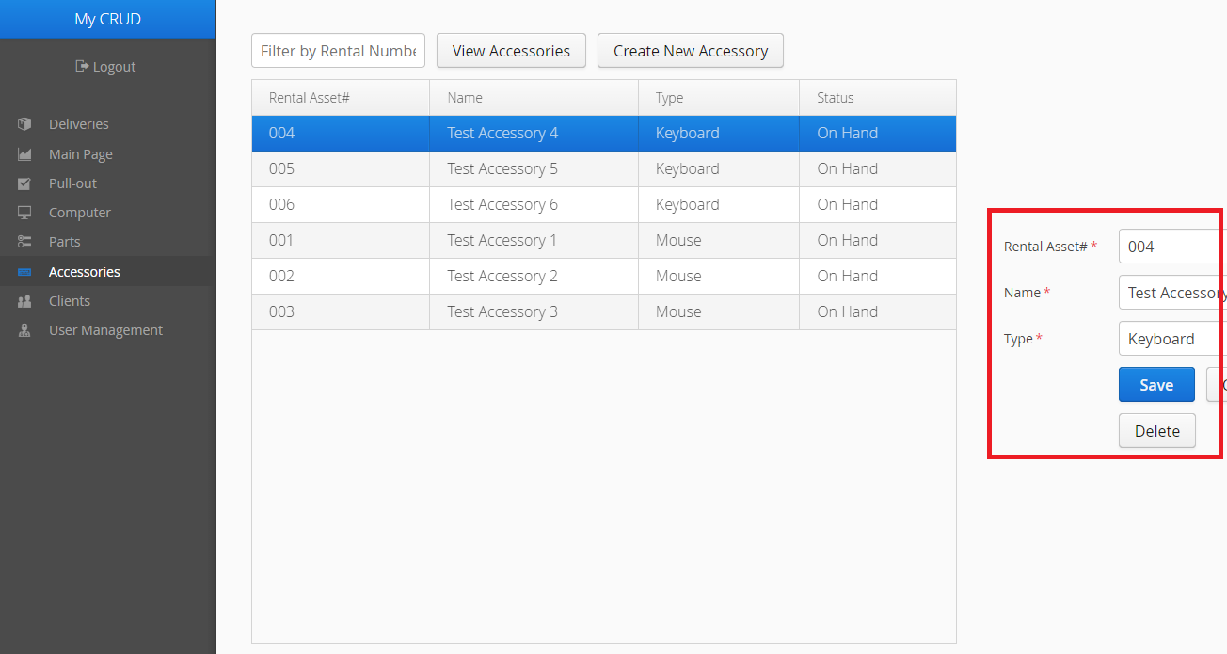**Step 2**: Follow the instructions for creating a new Accessory from step 2.

**Computers**

**View the list of all Computers**

**Step 1**: Click on the Computer tab in the Menu bar.

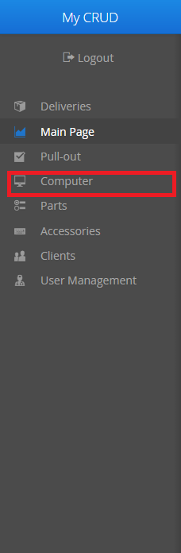

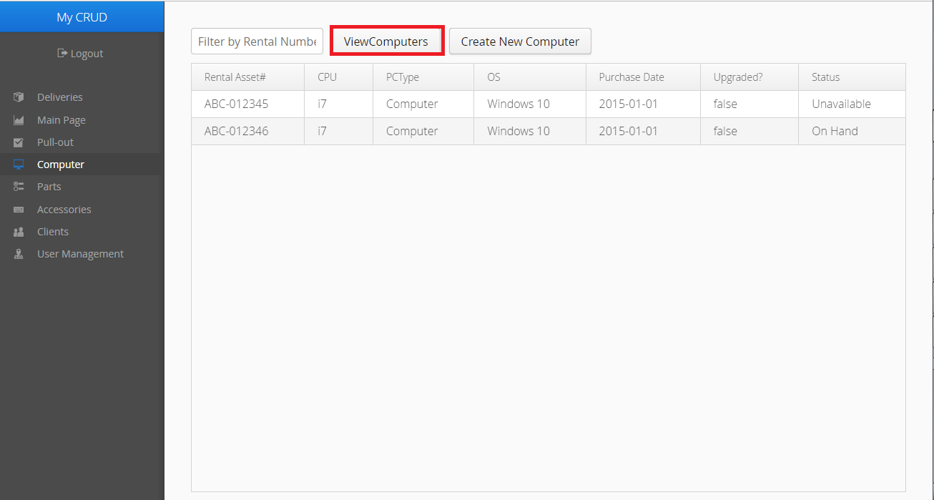**Step 2**: The list of Computers should already be filled. If you want to refresh the list, click the View Computers button.

**Encoding and Editing Computers**

To encode and edit Computers, your role must be Admin or higher.

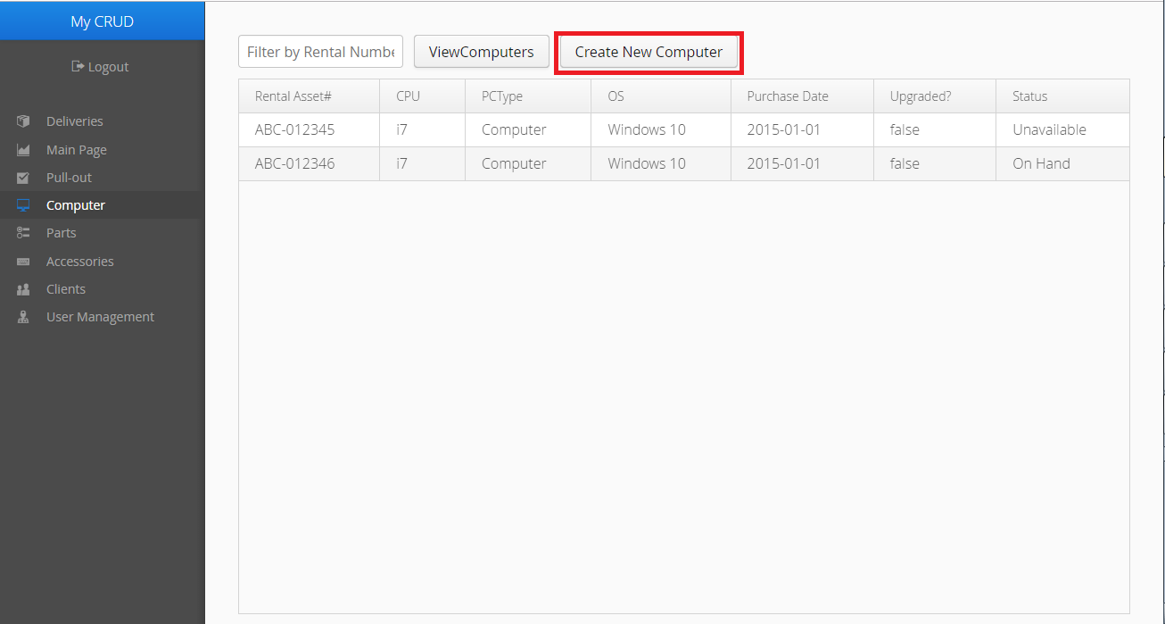**Step 1**: Click the Create New Computer button. An empty form should appear.

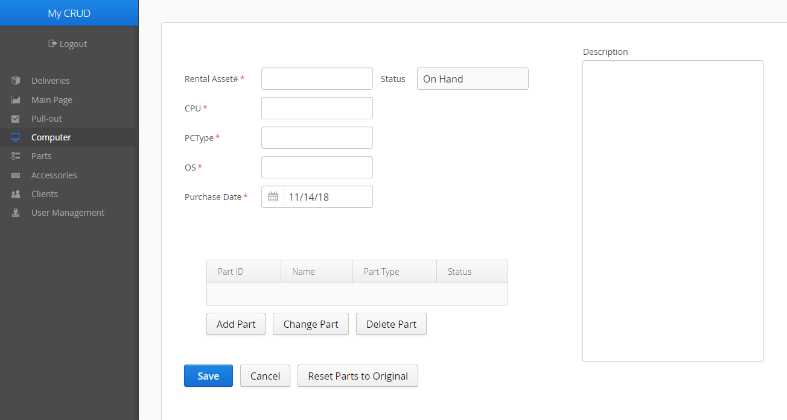**Step 2**: Fill in the necessary fields. The form will not be saved to the server if the fields with red asterisks are not filled.

**Step 2a**: When Adding or Changing Parts for the Computer, you can filter Parts by their Part ID using the filter highlighted below.

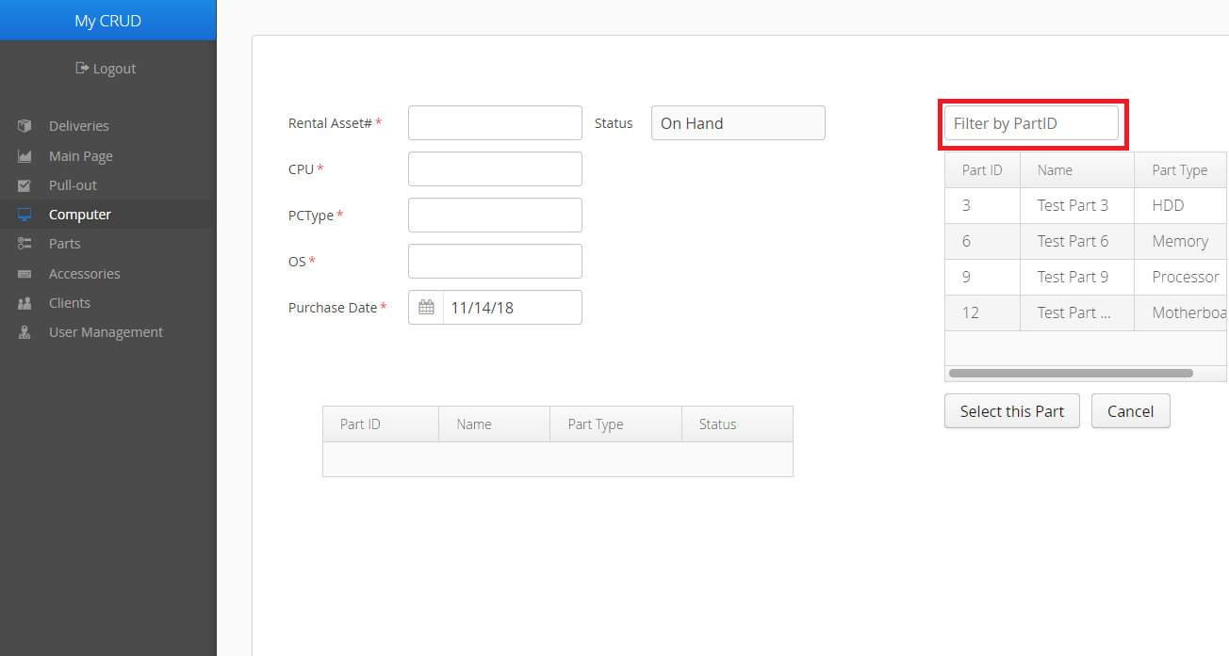

**Step 2b**: To remove a Part from the Computer, click on it in the list, then click the Delete Part button. This will not remove it from the inventory, only from the Computer.

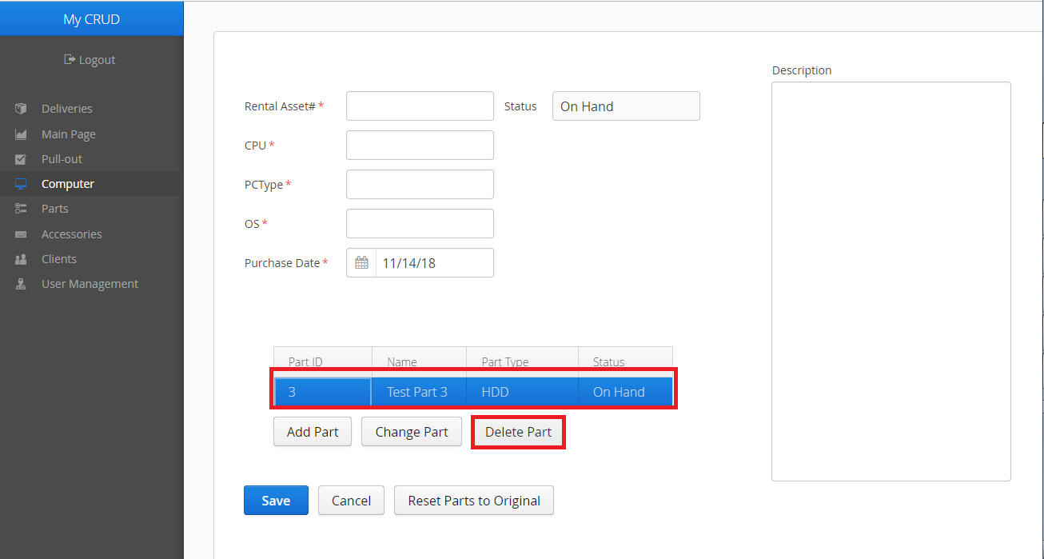

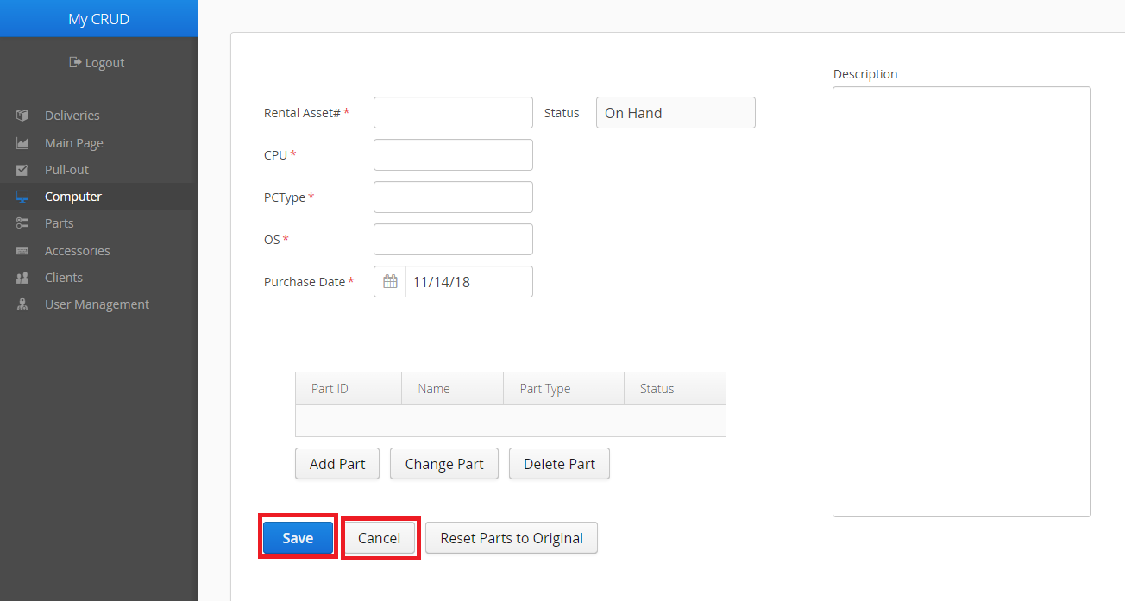**Step 3:** Click the Save button at the bottom of the form if you are finished. Click the Cancel button if you would like to discard the form instead.

Editing Computers follow a similar procedure.

**Step 1**: From the list of Computers, click on the Computer you would like to edit. A form filled out with that Computer’s information should appear.

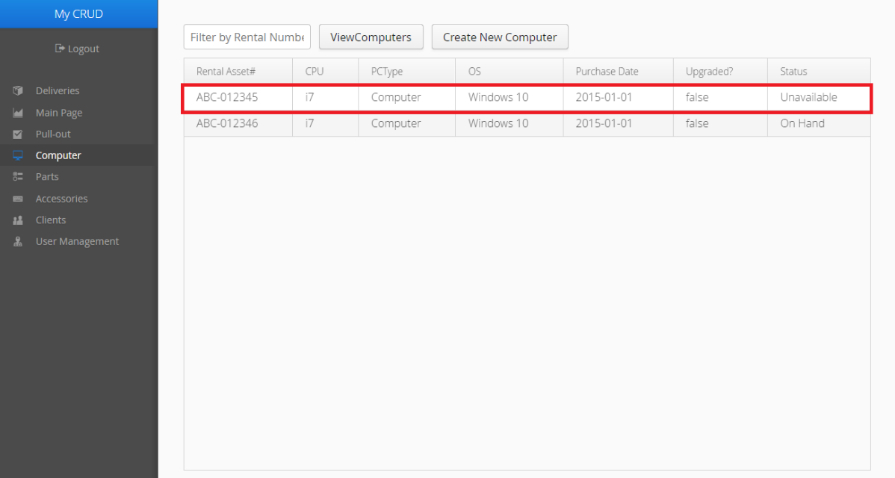

**Step 2:** Follow the instructions from creating a new Computer from Step 2.

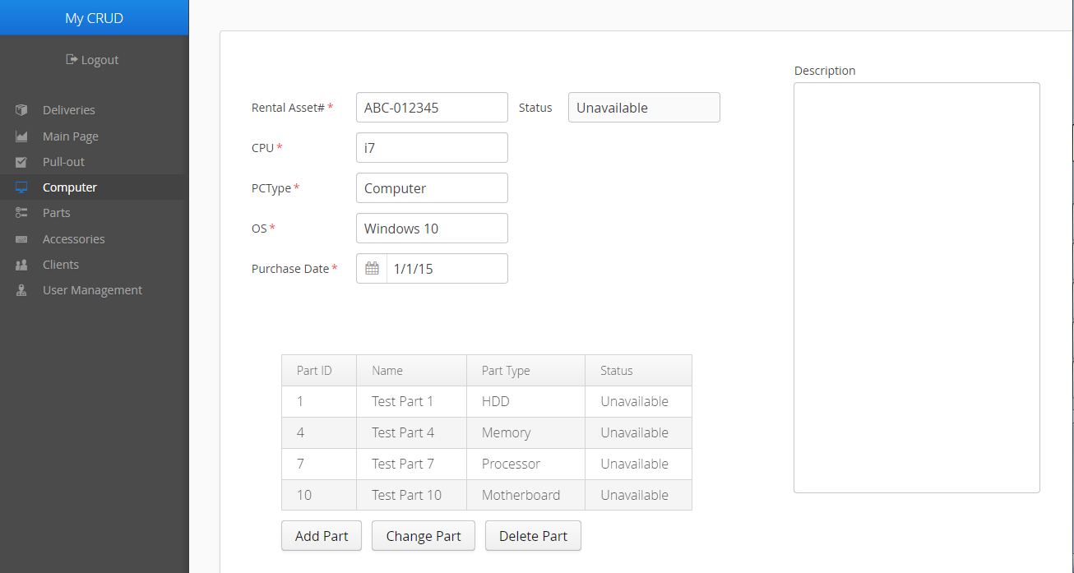

**Clients**

**View the list of all Clients**

**Step 1**: Click on the Clients tab in the Menu bar.

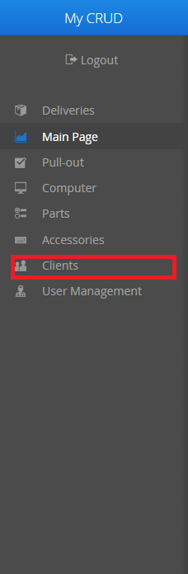

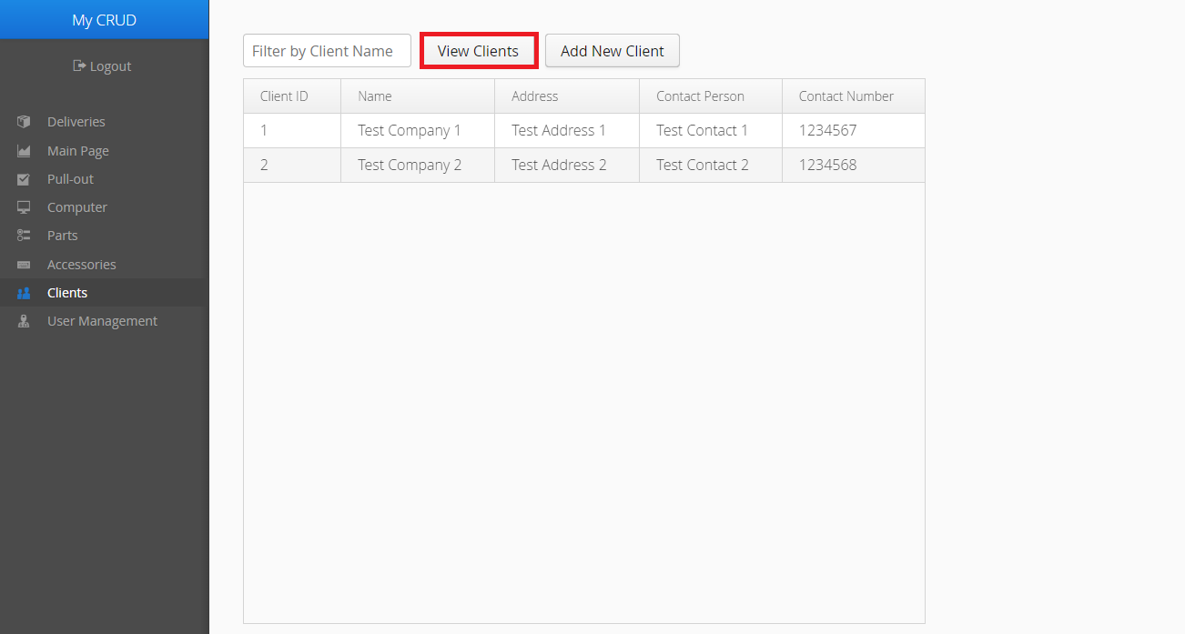**Step 2**: The list of Clients should already be filled. If you would to refresh the list, click on the View Clients button.

**Encoding and Editing Clients**

You must be an Admin or higher in order to encode and edit Clients.

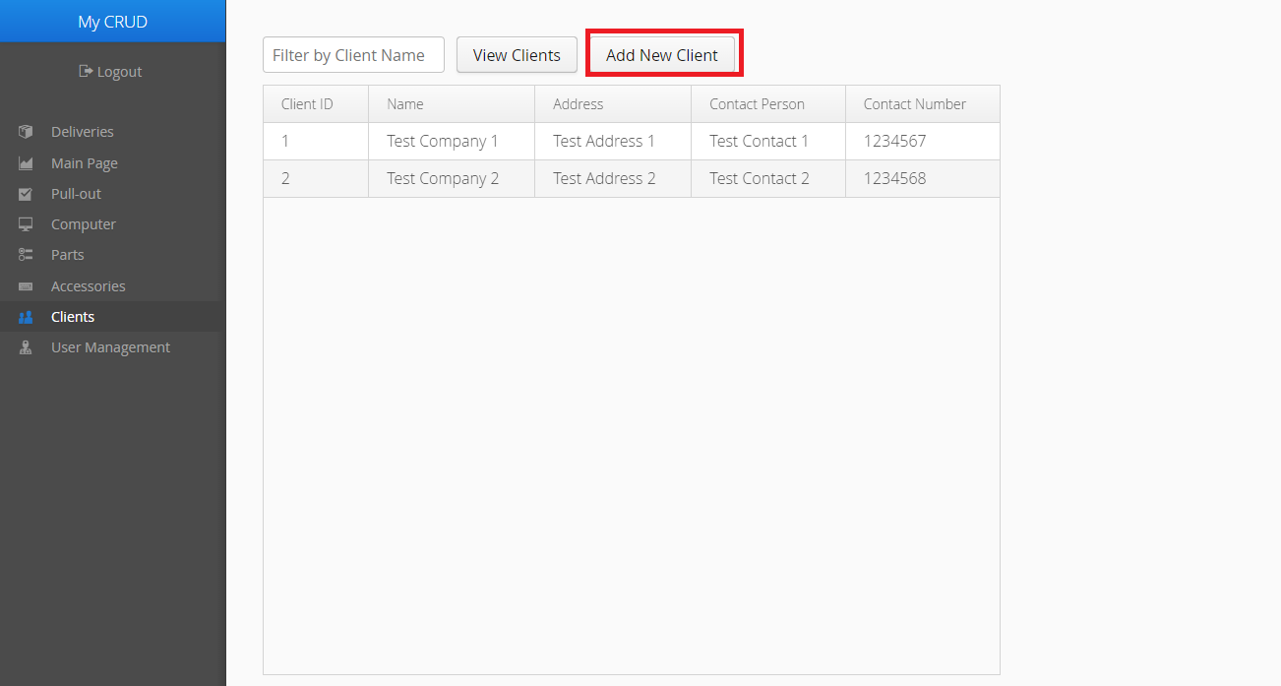**Step 1**: To create a Client, click on the Add New Client button. An empty form should appear on the right-hand side of the screen.

**Step 2**: Fill in the fields where necessary. If you cannot fill in the fields with red asterisks, the form cannot be saved to the server.

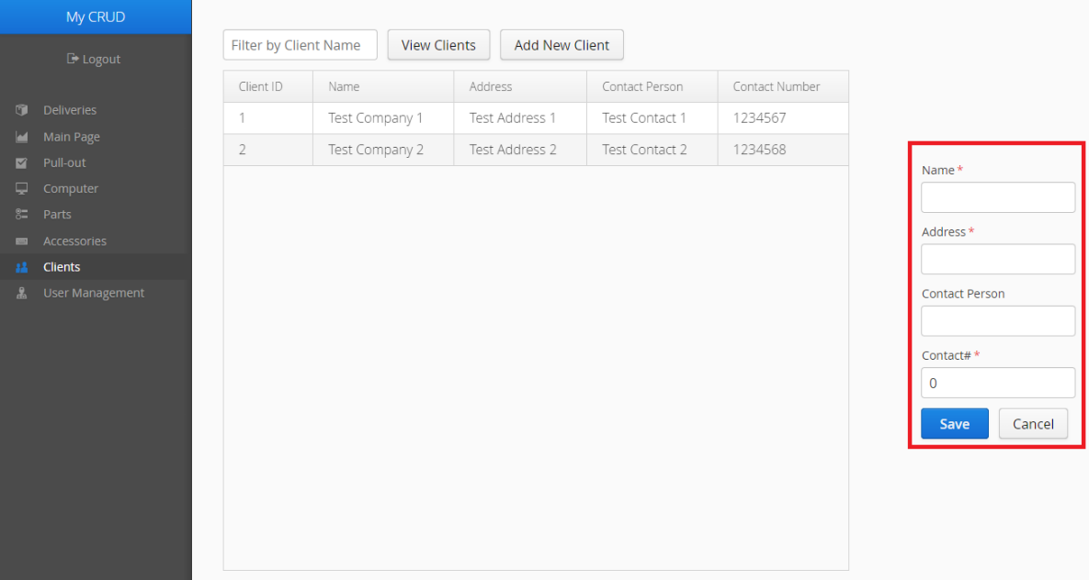

**Step 3**: Click the Save button when you are finished. Click Cancel if you would like to discard the form instead.

The process of editing Clients is the same.

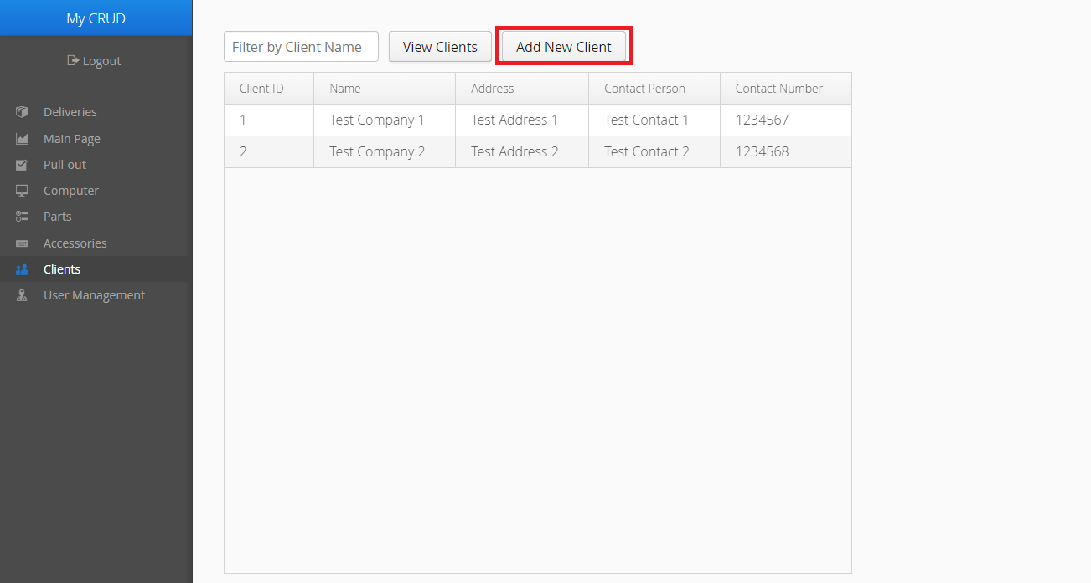**Step 1**: From the list of Clients, click on the Client you would like to edit. The form that will appear should be filled out with the chosen Client’s data.

Step 2: Follow the instructions for creating Clients from step 2.

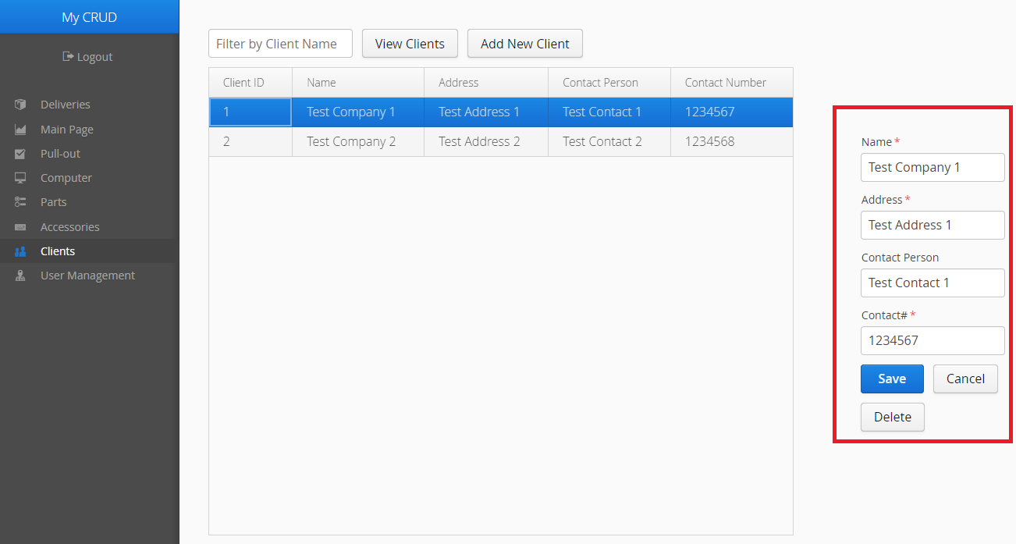

**Generate Rental Forms**

Before the delivery of Rental Units to a Client, these forms are needed to finalize the rental order the Client has placed.

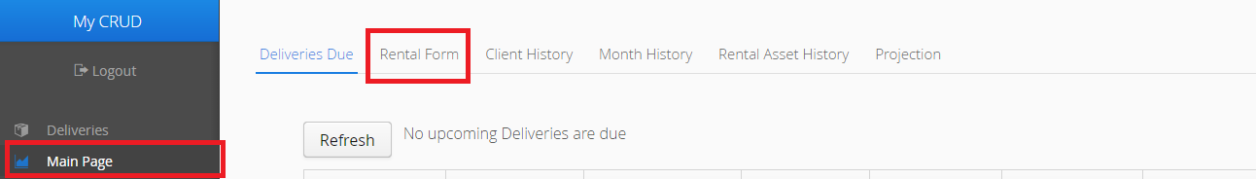**Step 1**: Click on the Main Page tab in the Menu bar, then click on the Rental Form tab in the Main Page.

**Step 2**: Enter the Delivery ID you would like to generate a form for, then click the Generate Form button.

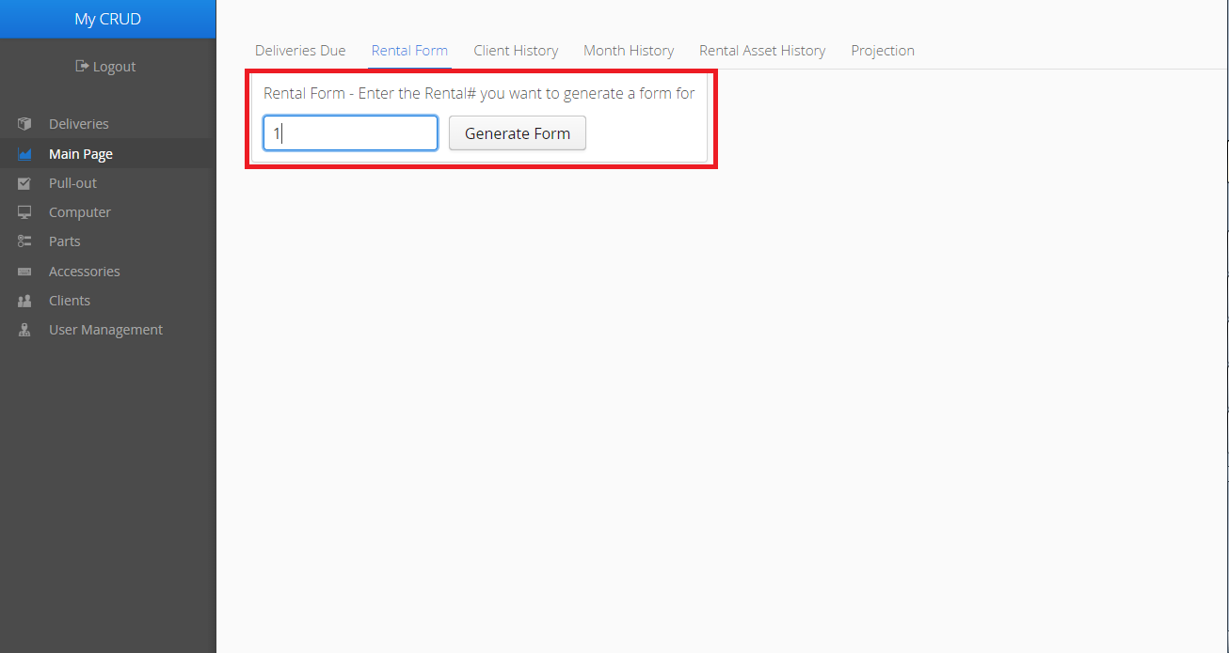

**Step 3**: Click the Print this form button. A separate window should appear.

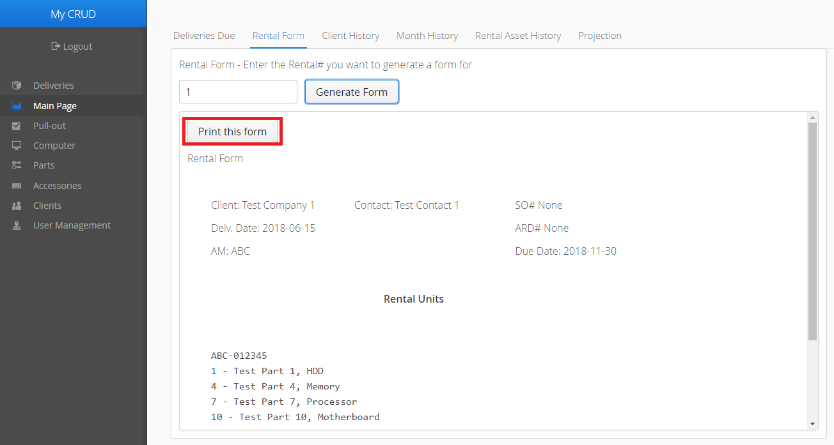

**Step 4**: In the new window, press CTRL and the P key to print the Rental form. A Print dialog should appear where you can adjust print settings and print the document. Be sure to select the Rental Requirement Form Window before pressing CTRL + P.

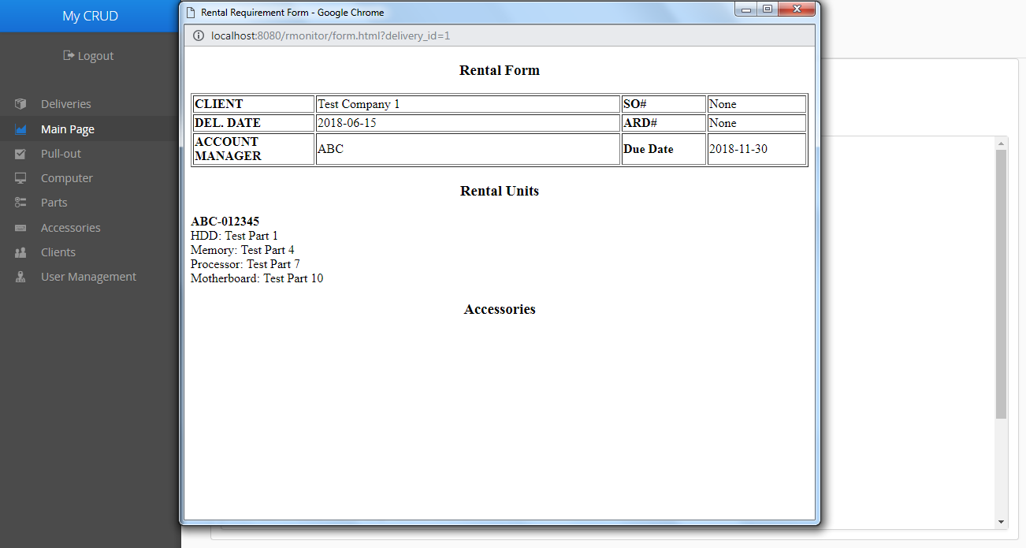

**Pull-outs**

Pull-outs should be generated when Client deliveries expire and have to be returned to the inventory of Computers.

To view the List of Pull-outs, simply click on the Pull-out tab in the Menu bar.

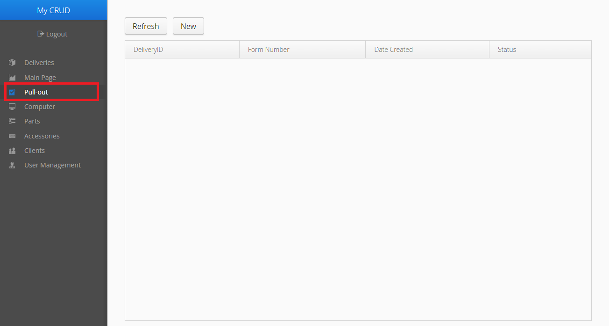

The list of Pull-outs will already be filled if there are any existing Pull-outs in the database. If you want to refresh the list, click the Refresh button above.

**Creating new Pull-outs**

You must have a role of Reports or above to Pull-out Deliveries.

**Step 1**: From the Pull-out page, click the New button. You will be taken to a new page.

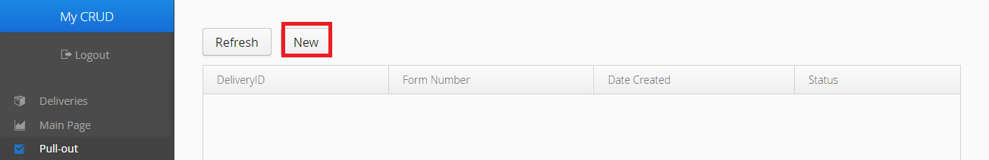

**Step 2**: Enter the Delivery number for the Delivery you would like to Pull-out, then click the Search button.

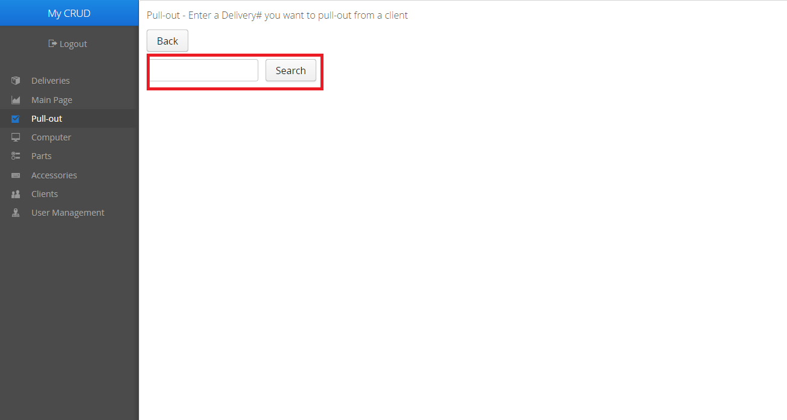

**Step 2a**: If the Delivery exists, you will then need to enter a Pull-out number for your new Pull-out. When you are finished, click the Create New Pull-out button.

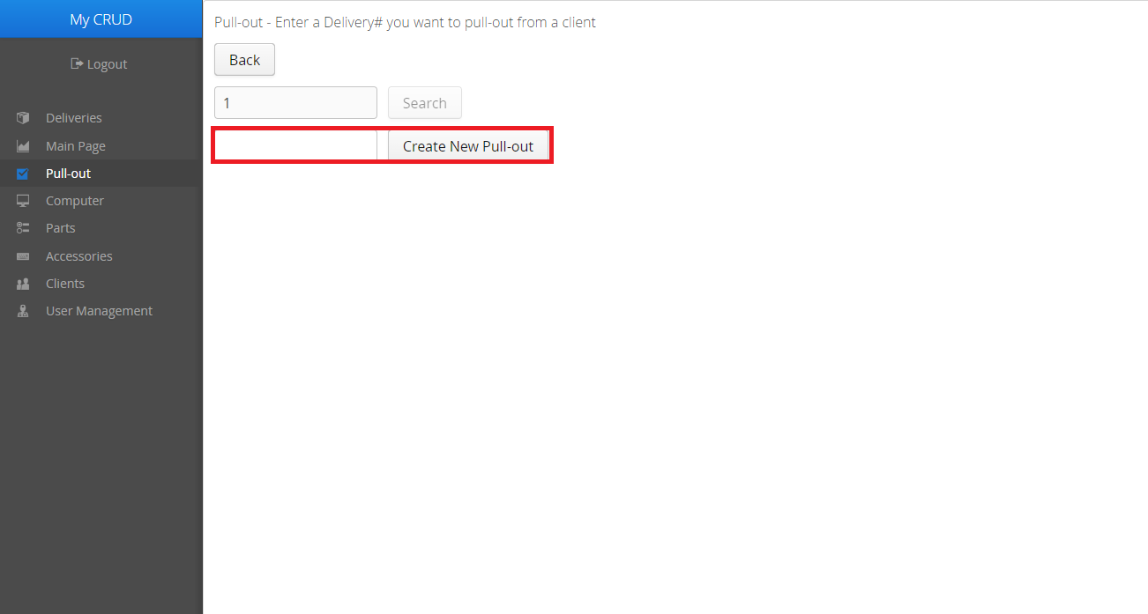

At this point, the Pull-out has been created. You can perform various tasks with a Pull-out, which will be covered below.

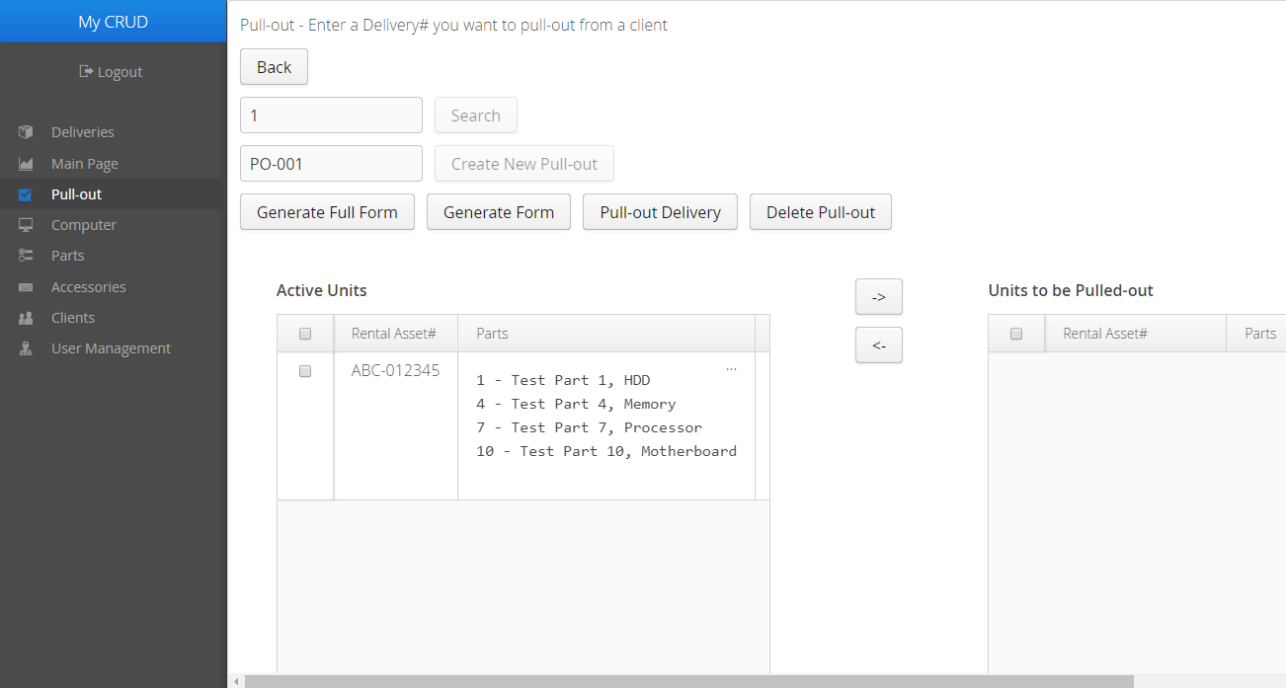

**Printing a Pull-out form**

There are two forms that you can print out. The first one is the full Pull-out form, which includes all the Rental Units in the Delivery. This form can be printed by clicking the Generate Full Form button.

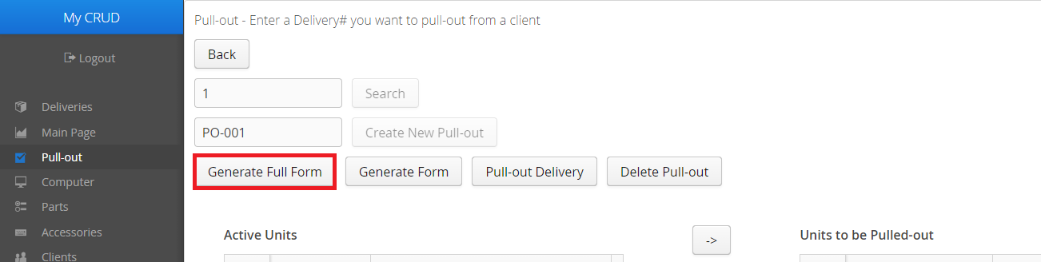

In the new window, press CTRL and the P key to print the Pull-out form. A Print dialog should appear where you can adjust print settings and print the document. Be sure to select the Pull-out Form window before pressing CTRL + P.

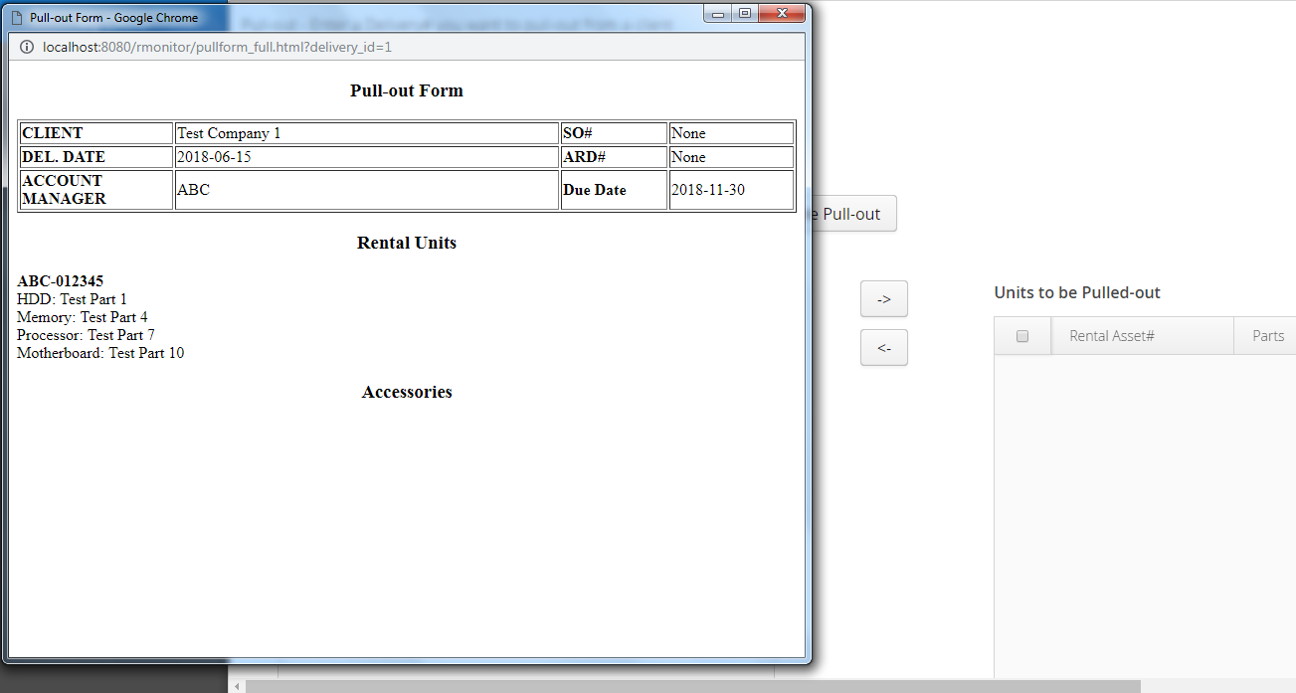

The second form that you can print is the partial Pull-out form. This form will only include Rental Units that are in the list of Units to be Pulled-out. This form can be printed by clicking the Generate Form button.

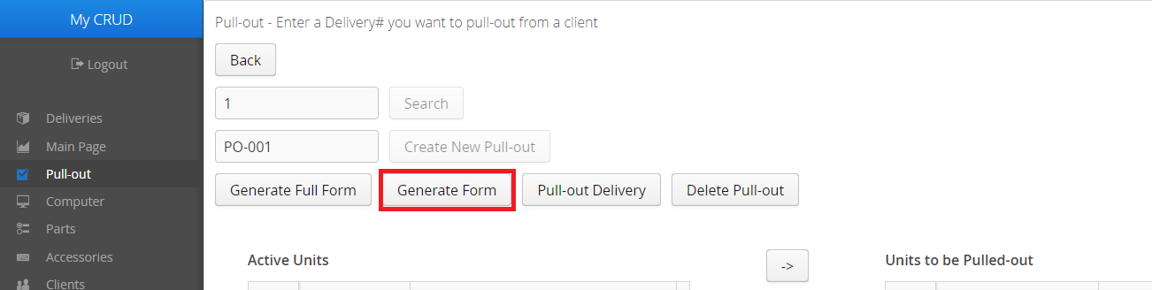

In the new window, press CTRL and the P key to print the Pull-out form. A Print dialog should appear where you can adjust print settings and print the document. Be sure to select the Pull-out Form window before pressing CTRL + P.

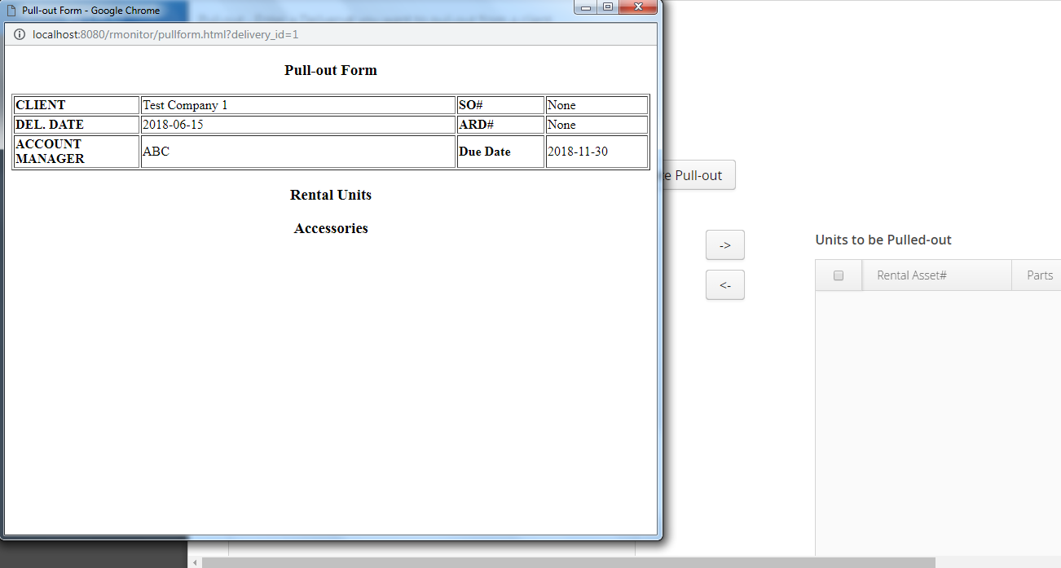

**Mark Units to be Pulled-out**

**Step 1**: In the Pull-out form, select from the list of Active Units or Active Accessories the Units you would like to Pull-out. Click the box at the header of the list to select all the Units, or click the boxes of each Unit you would like to Pull-out.

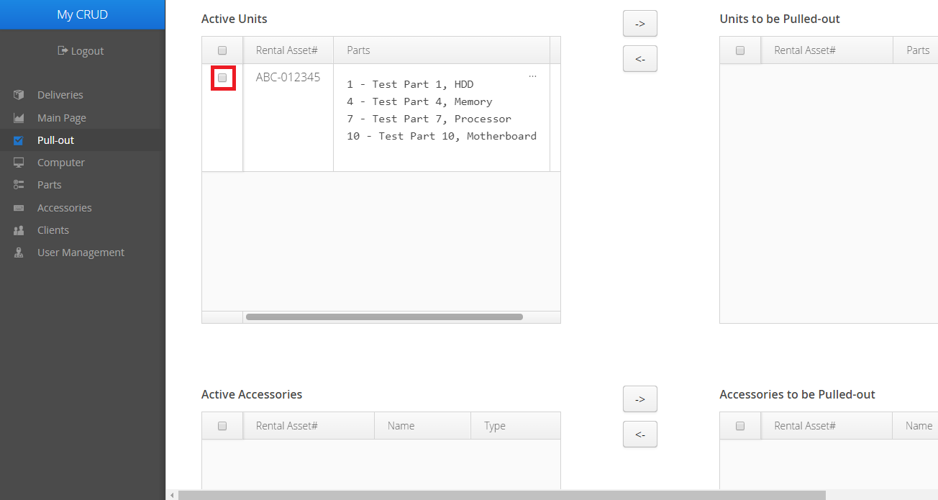

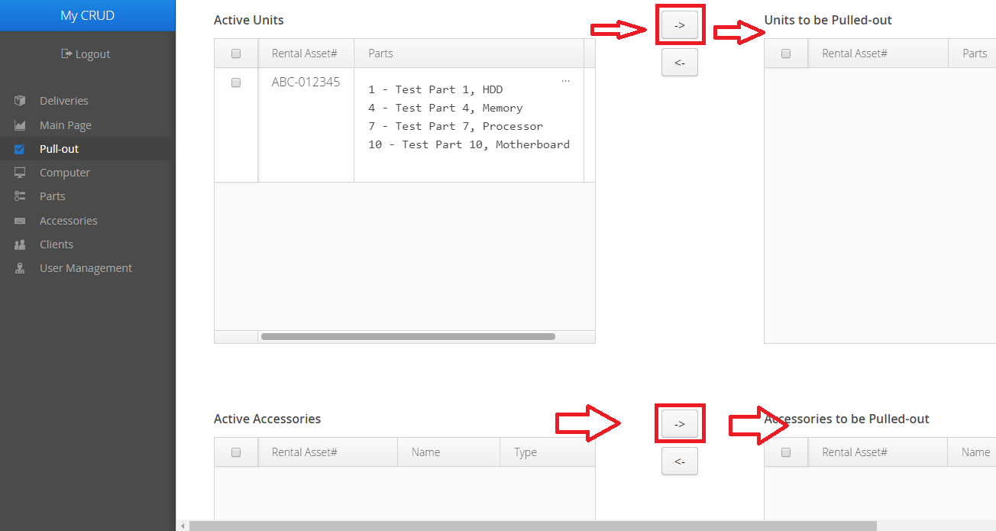**Step 2**: With your Units selected, click the Left Arrow button on the corresponding row. You can only transfer between the Units row or the Accessories row in any given attempt, as your Units or Accessories will deselect after every operation.

**Step 3**: A confirmation dialog will appear. Click the OK button to proceed.

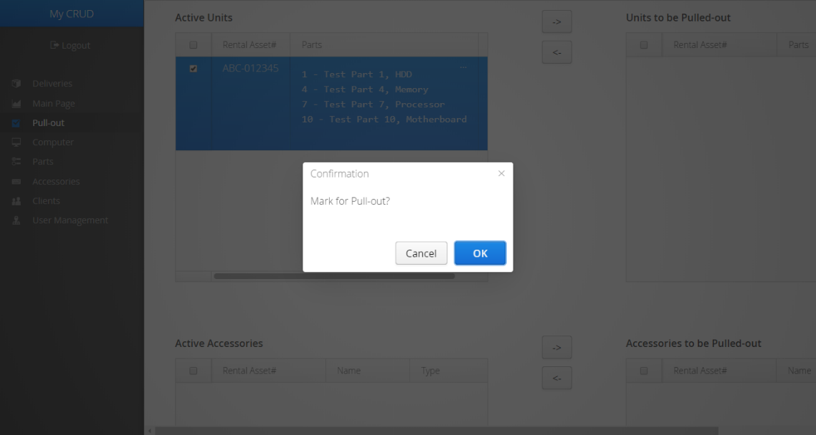

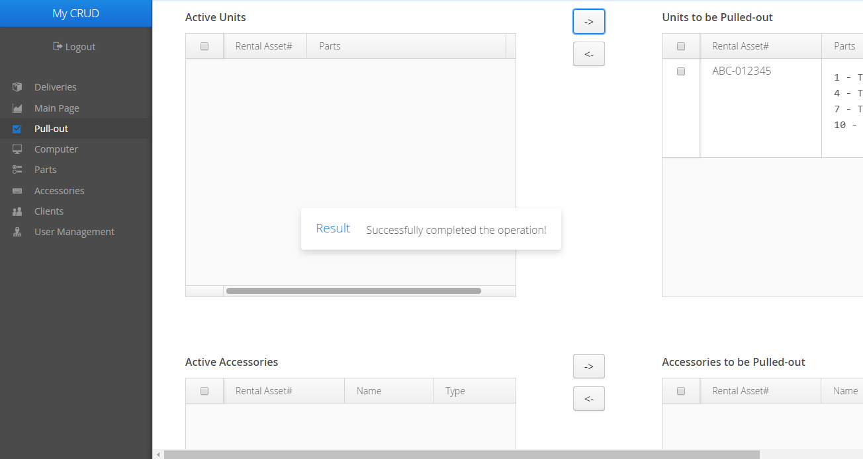A notification should appear to inform you of the success (or failure) of the operation. If successful, the page will reflect the changes to the status of your Units, as seen on the right-hand side of the picture below.

You may also repeat this process in reverse to transfer the Units to be pulled out back into Active status. Select the Units to be Pulled-out, then click the Right Arrow button and confirm your choice.

**Return Units**

If the Units to be Pulled-out are ready to be returned to the inventory, click on the Pull-out Delivery button.

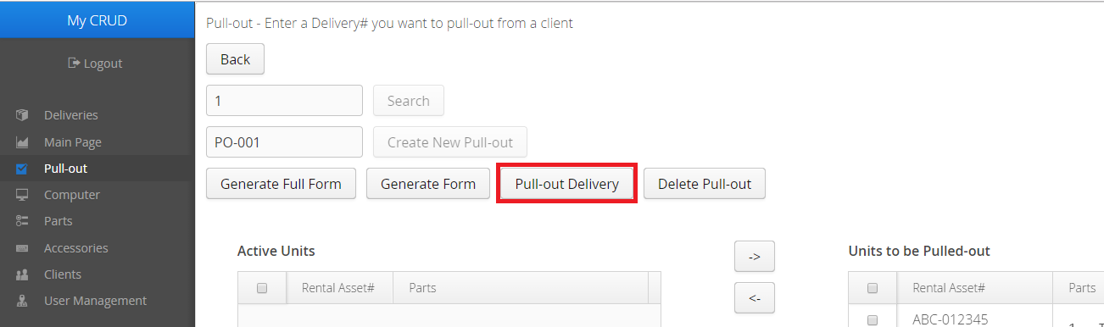

A confirmation dialog will appear. Click the OK button to confirm your choice.

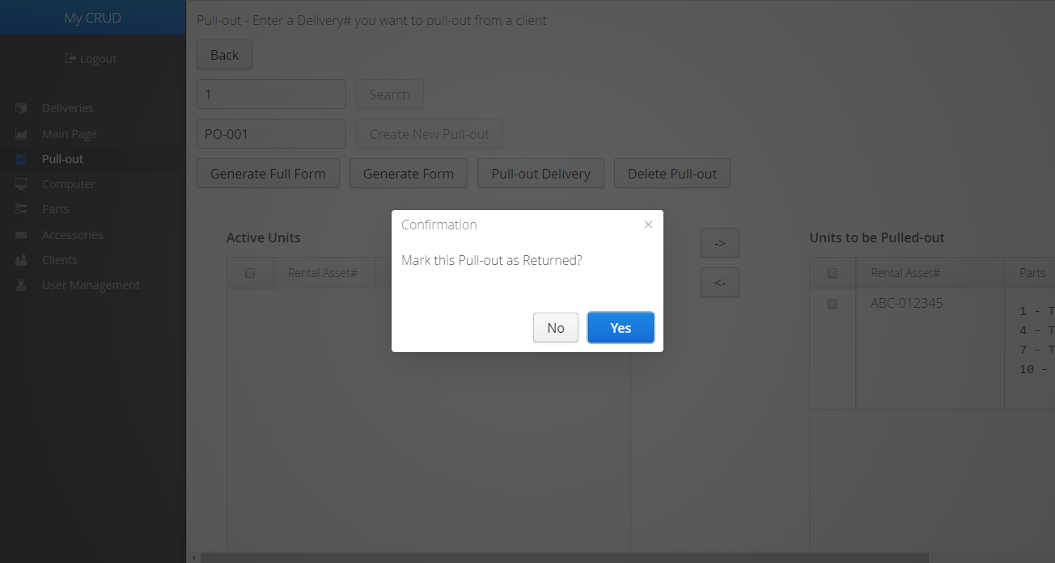

A notification should appear to inform you of the success (or failure) of the operation. If successful, you will be returned to the main Pull-out page.

**Deleting a Pull-out form**

In case you need to delete a Pull-out form, simply click the Delete Pull-out button on the Form you wish to delete.

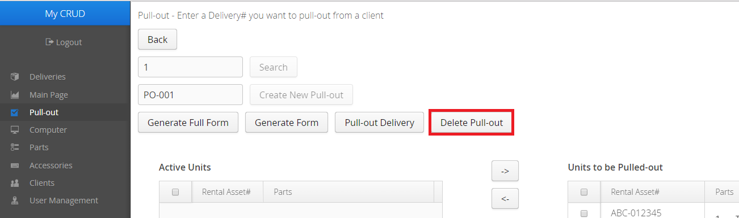

A confirmation dialog will appear. Click the OK button to confirm your choice.

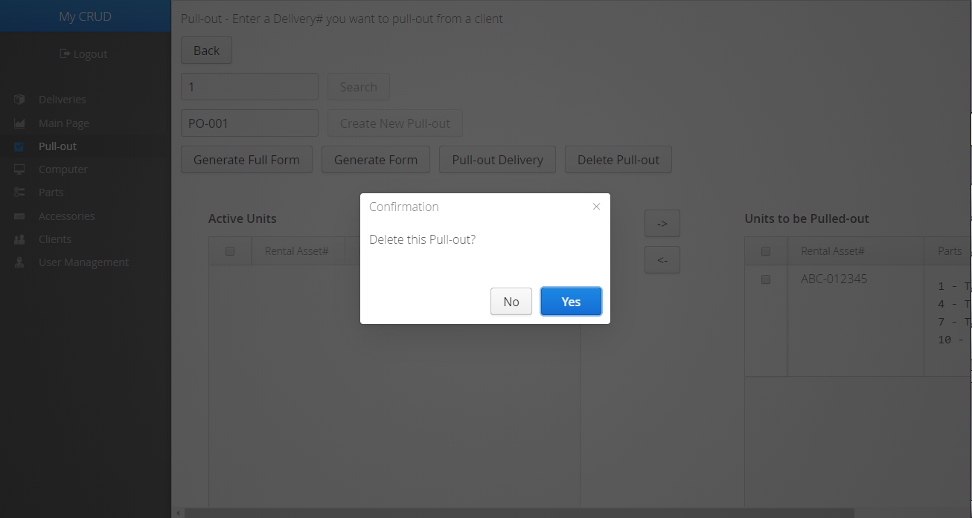

A notification should appear to inform you of the success (or failure) of the operation. If successful, you will be returned to the main Pull-out page.

**View various summaries about the inventory**

**Deliveries Due**

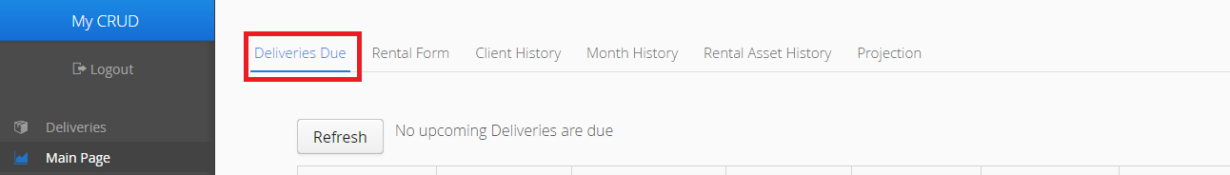**Step 1**: From the Main Page, click on the Deliveries Due tab. The list should already be filled, if there are Deliveries about to expire in a week.

Click the Refresh button shown above to refresh the list.

**Client History**

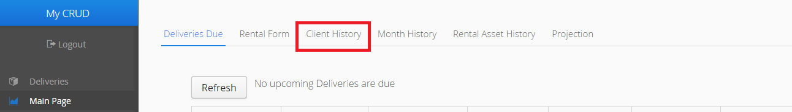**Step 1**: From the Main Page, click on the Client History tab.

**Step 2**: Enter the exact name of a Client, then click the Find Client button.

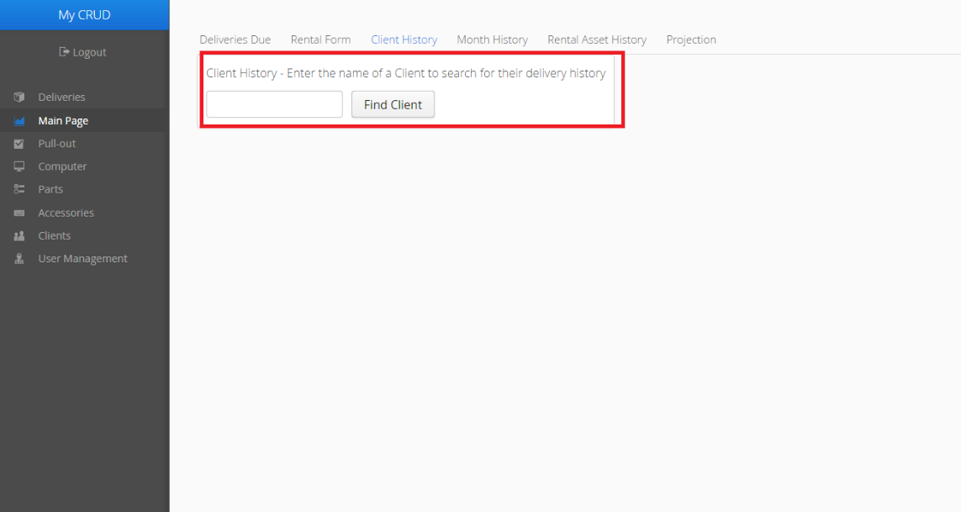

A list of Deliveries for this Client should appear below the search bar. You can click on the Delivery to show the Rental Form for it on the right-hand side of the list.

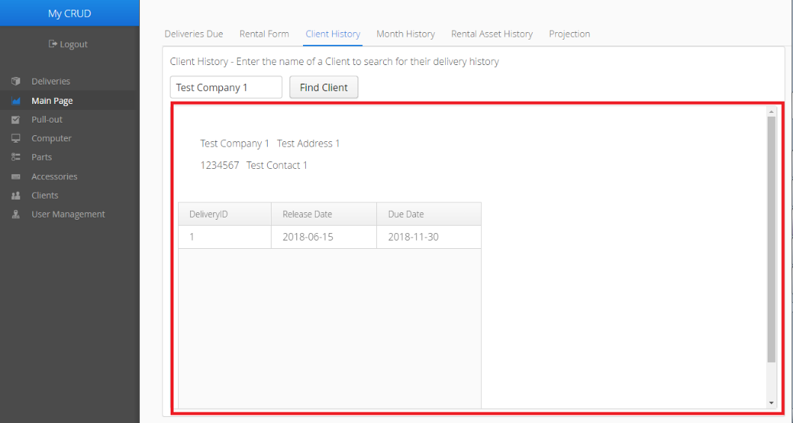

**Month History**

**Step 1**: From the Main Page, click the Month History tab.

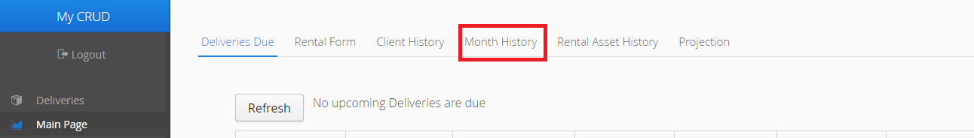

**Step 2**: Choose a Date that matches the Month and the Year you would like to check, then press the Go button.

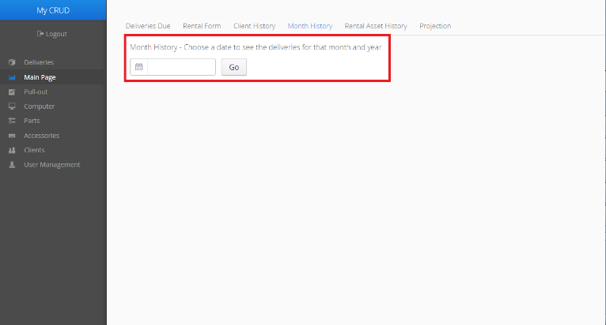

A list of Deliveries made within that Month of the Year should appear, if any Deliveries were made. You can click on the Delivery to show the Rental Form for it on the right-hand side of the list.

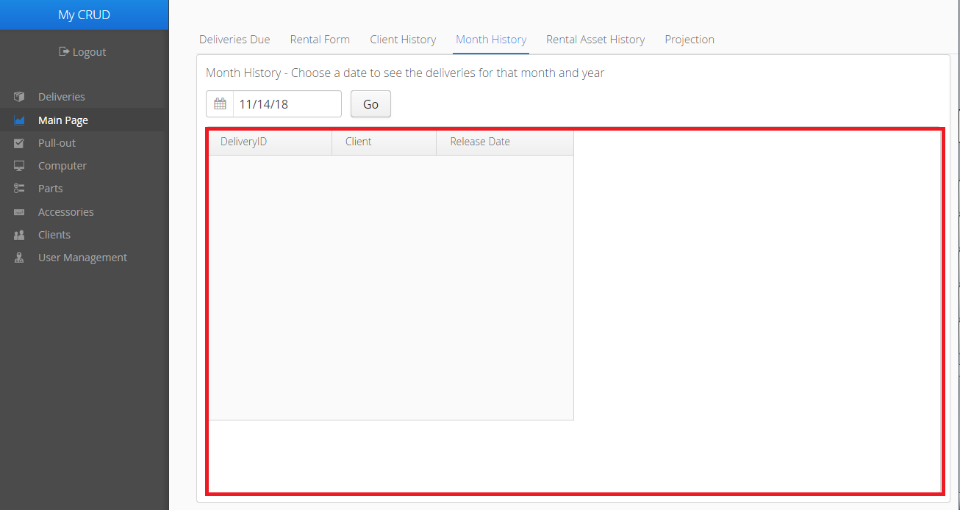

**Rental Asset History**

**Step 1**: From the Main Page, click the Rental Asset History tab.

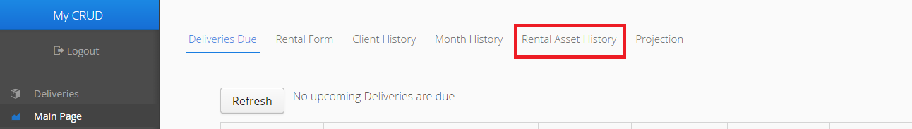**Step 2**: Enter the Rental number of a Computer or Accessory, then click the View Rental Unit History button.

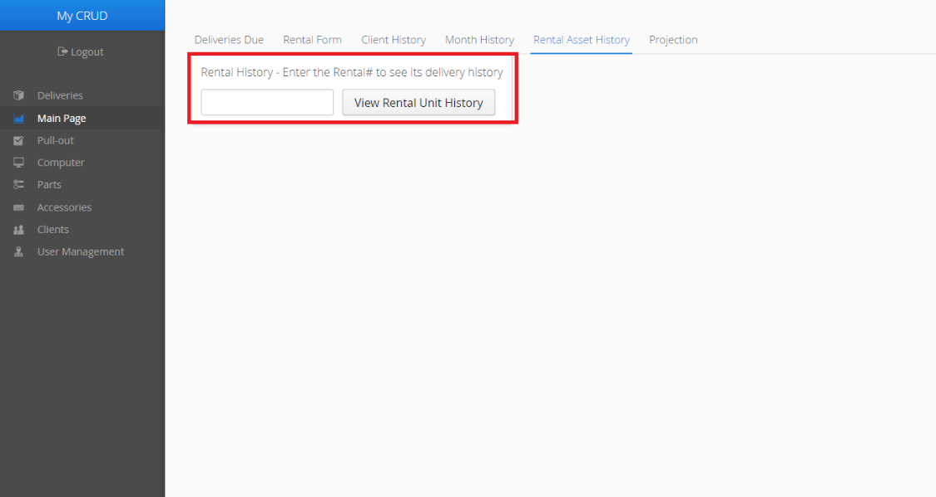

A list of Deliveries that the Rental Unit has been on should appear below the search bar. You can click on a Delivery to show the Rental Form for it on the right-hand side of the list.

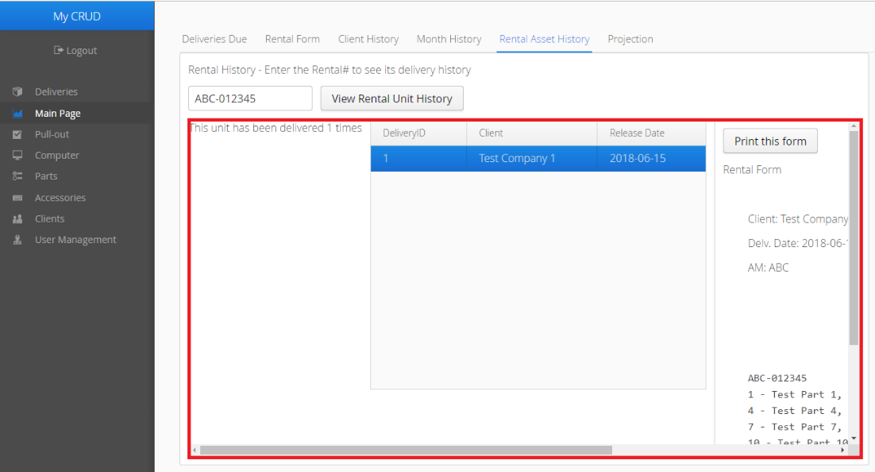

**Projection**

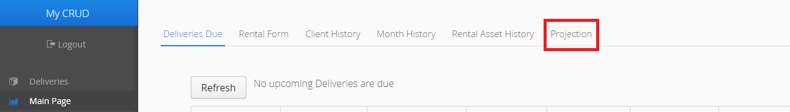**Step 1**: From the Main Page, click on the Projection tab.

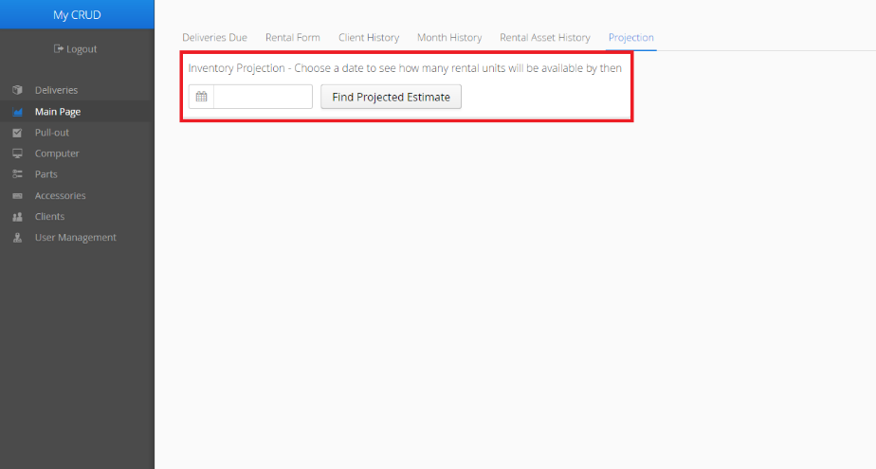**Step 2**: Enter a Date in the field below, then click the Find Projected Estimate button.

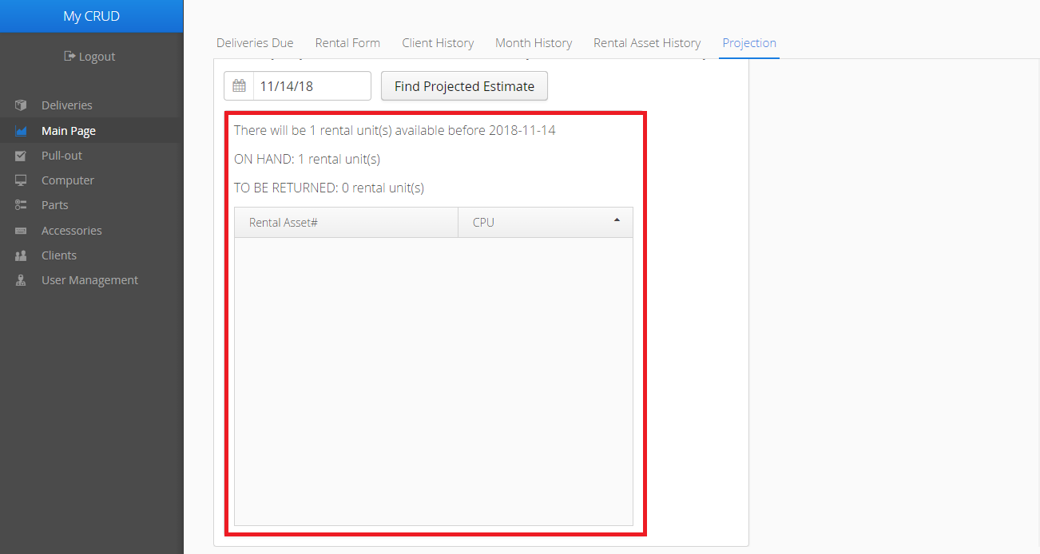A list of Rental Units that will be available by the Date you entered should appear, as well as how many there will be.

**User Management**

**Change Password**

**Step 1**: In the Menu bar, click the User Management tab, then click the Change Your Password button.

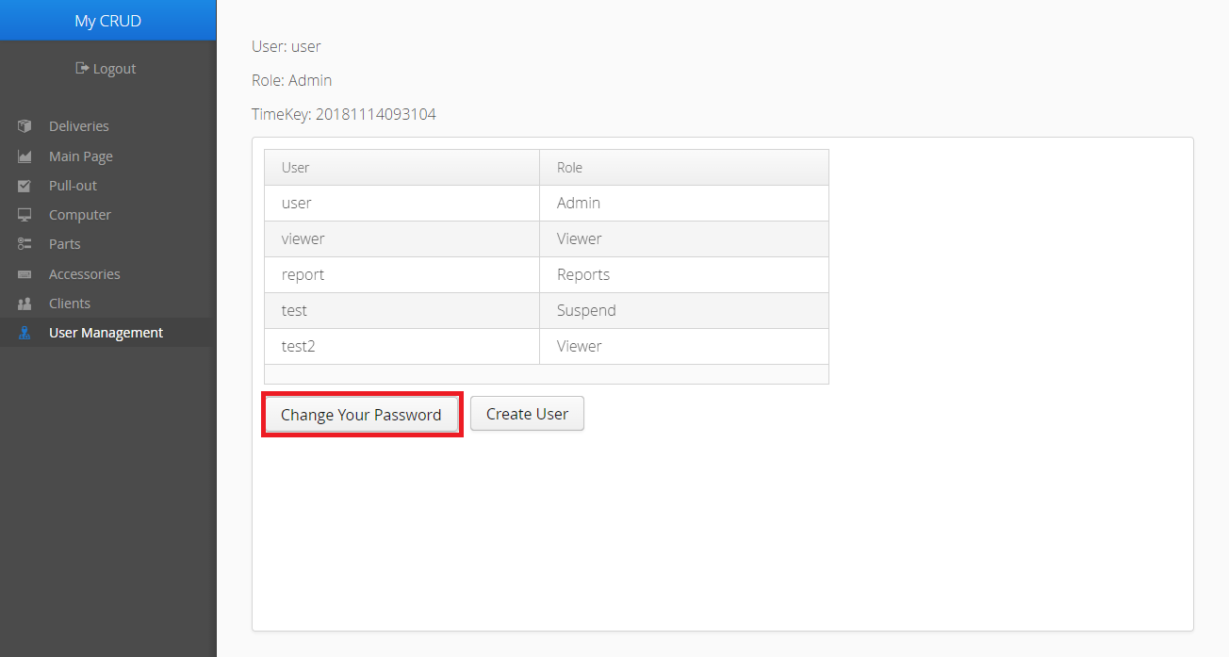

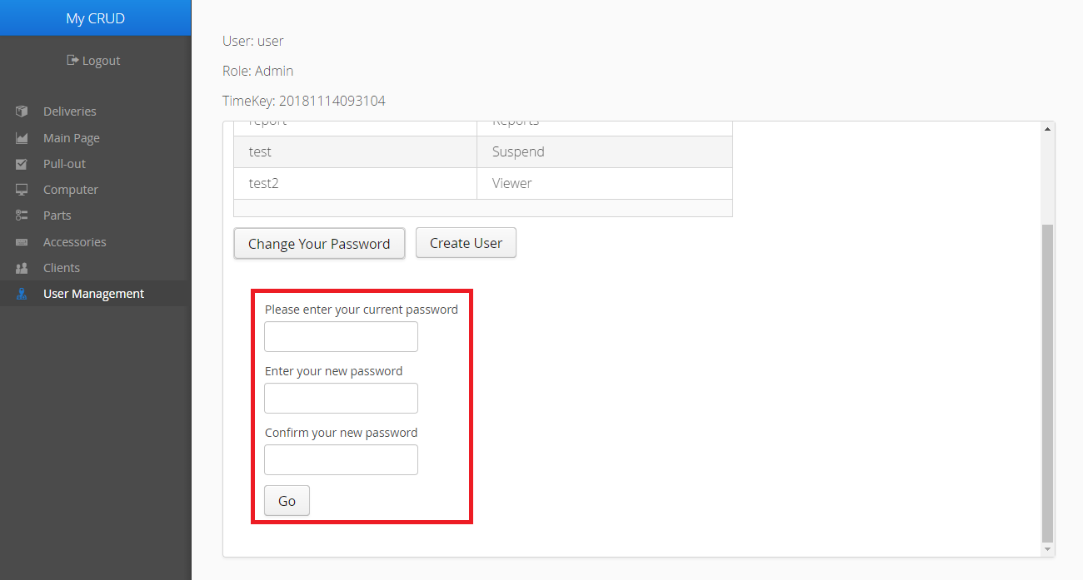**Step 2**: Fill in the fields below, then click the Go button.

**Step 3**: Click the Yes button in the confirmation dialog window that will appear.

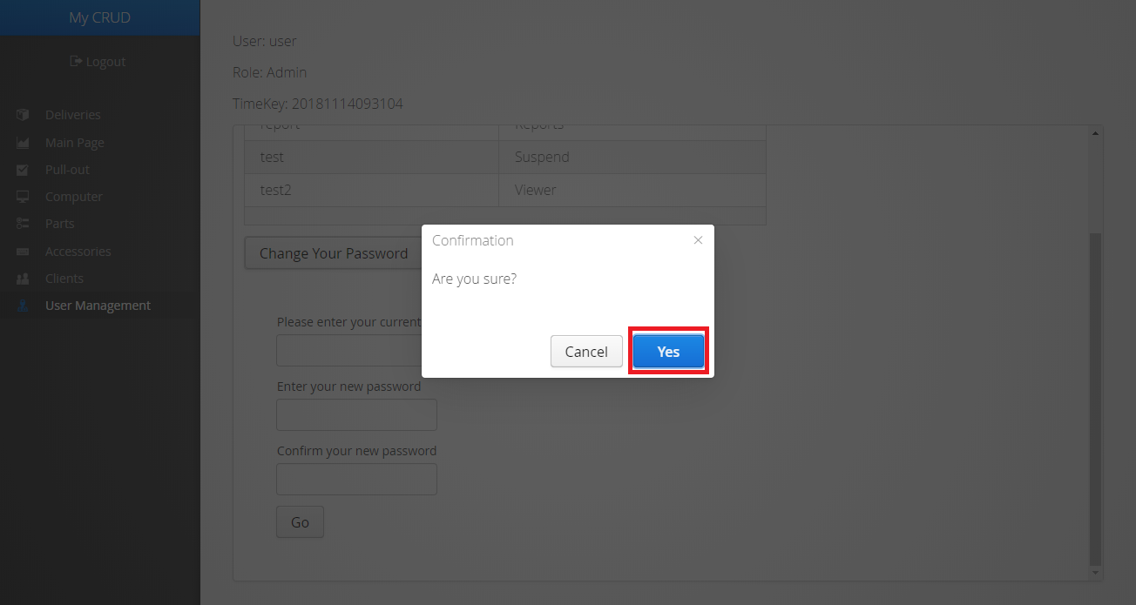

A message displaying the success (or failure) of the operation should appear afterward.

**Create User**

Your role must be Admin or higher to do this.

**Step 1**: In the Menu bar, click the User Management tab, then click the Create User button.

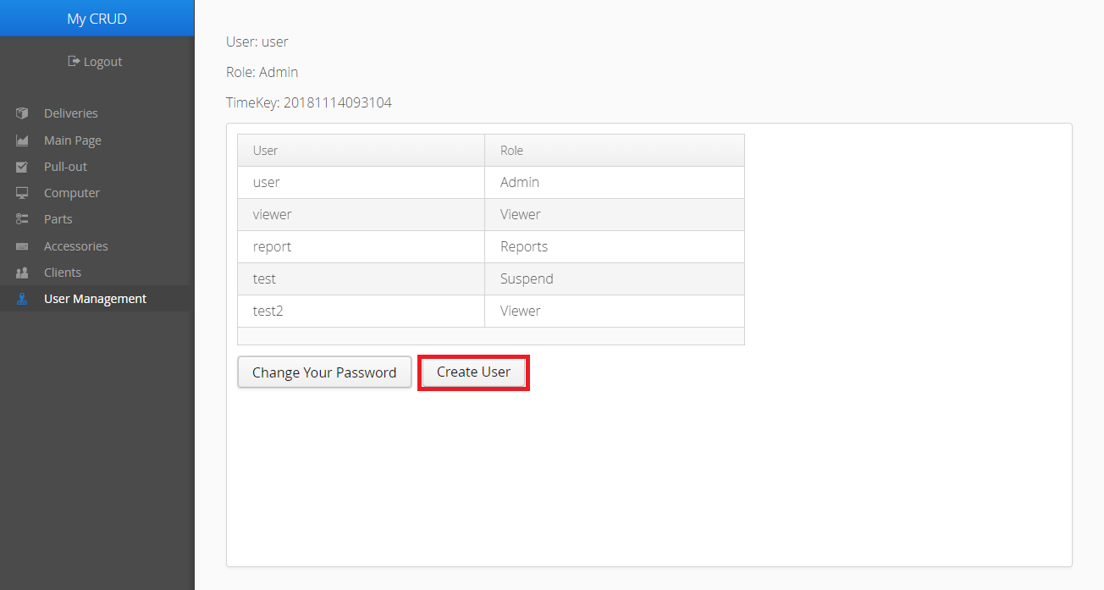

**Step 2**: Fill in all the fields below, then click the Go button.

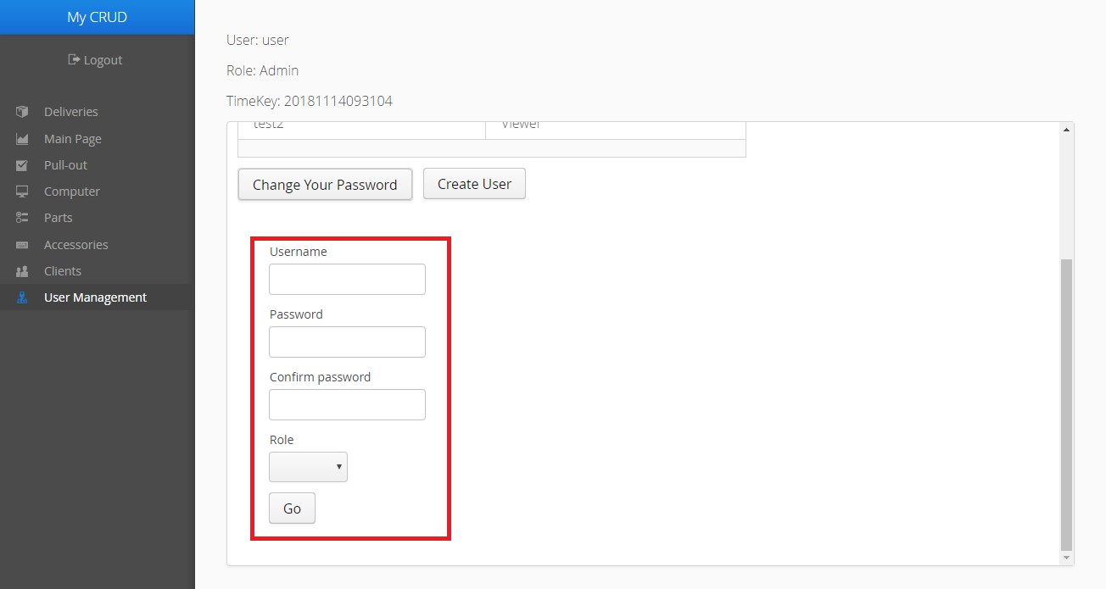

**Step 3**: Click the Yes button in the confirmation dialog window that will appear.



A message displaying the success (or failure) of the operation should appear afterward.

**Suspend User**

Your role must be Admin or higher to do this.

**Step 1**: In the Menu bar, click the User Management tab. In the list of Users, click the User who you want to suspend, then click the Suspend User button that will appear below.

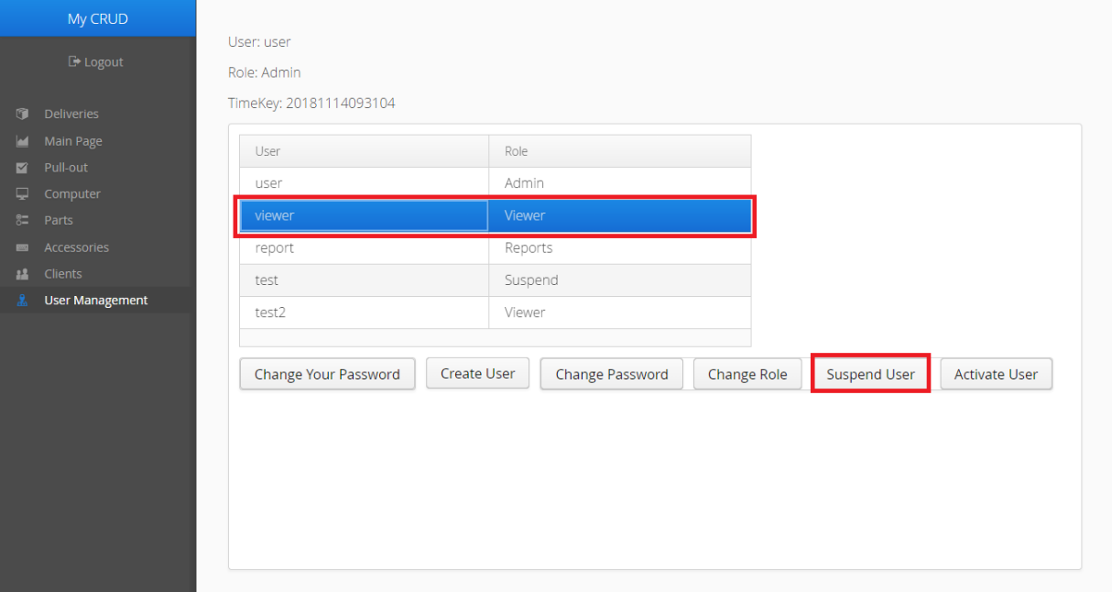

**Step 2**: Click the Yes button in the confirmation dialog window that will appear.

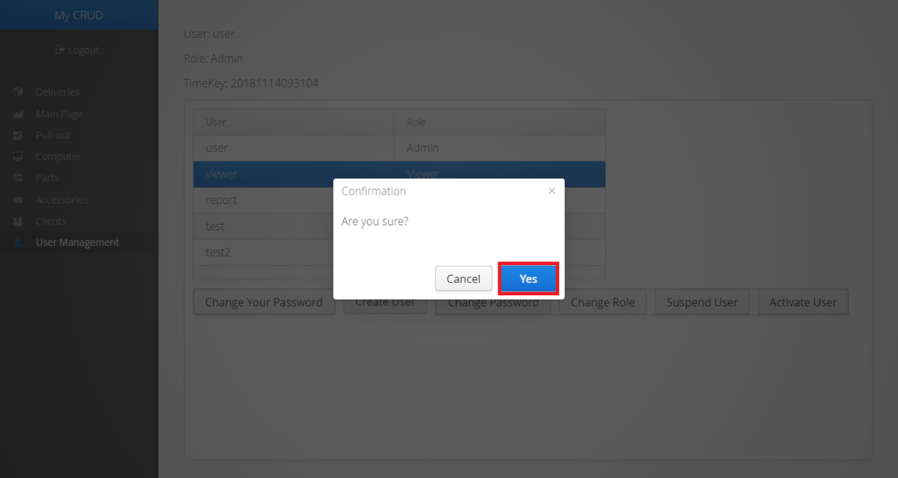

A message displaying the success (or failure) of the operation should appear afterward.

**Activate User**

Your role must be Admin or higher to do this.

**Step 1**: In the Menu bar, click the User Management tab. In the list of Users, click the User who you want to activate, then click the Activate User button that will appear below.

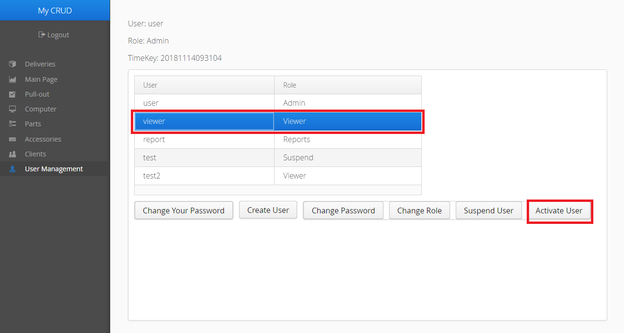

**Step 2**: Click the Yes button in the confirmation dialog window that will appear.

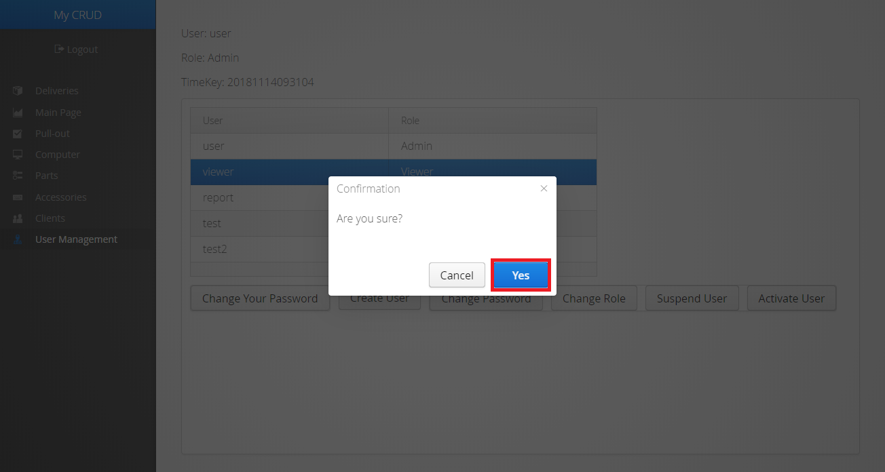

A message displaying the success (or failure) of the operation should appear afterward.

**Change a User’s Password**

Your role must be Admin or higher to do this.

**Step 1**: In the Menu bar, click the User Management tab. In the list of Users, click the User whose password you want to change, then click the Change Password button that will appear below.

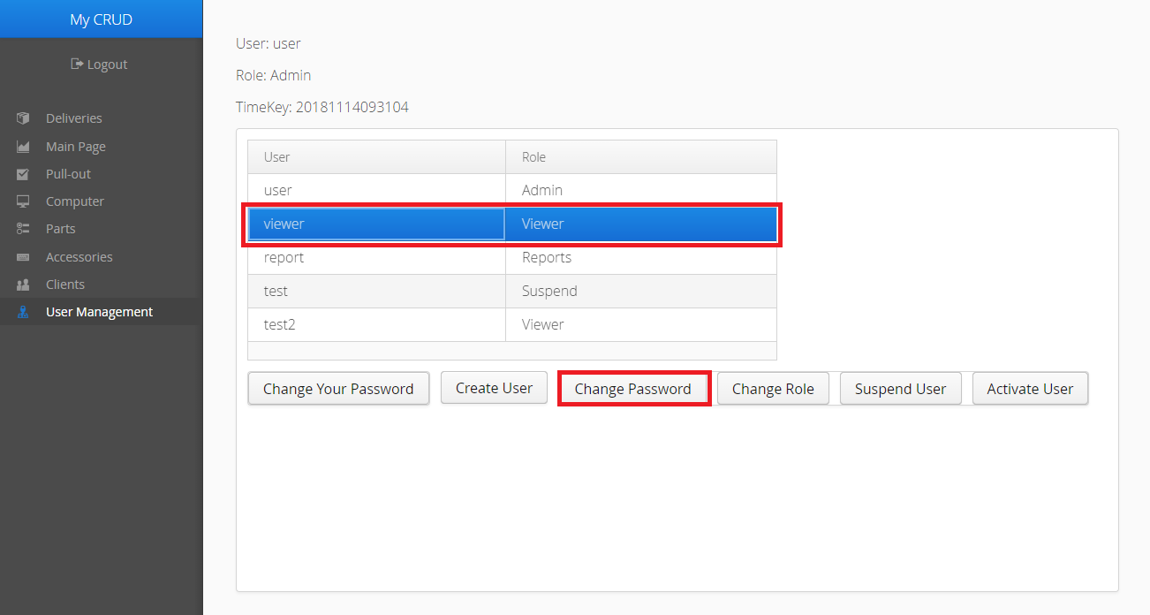

**Step 2**: Fill in all the fields below, the click the Go button.

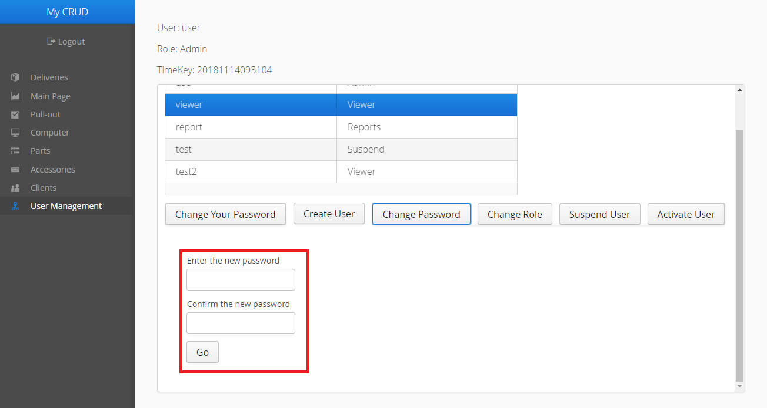

**Step 3**: Click the Yes button in the confirmation dialog window that will appear.



A message displaying the success (or failure) of the operation should appear afterward.

**Change a User’s Role**

Your role must be Admin or higher to do this.

**Step 1**: In the Menu bar, click the User Management tab. In the list of Users, click the User whose role you want to change, then click the Change Role button that will appear below.

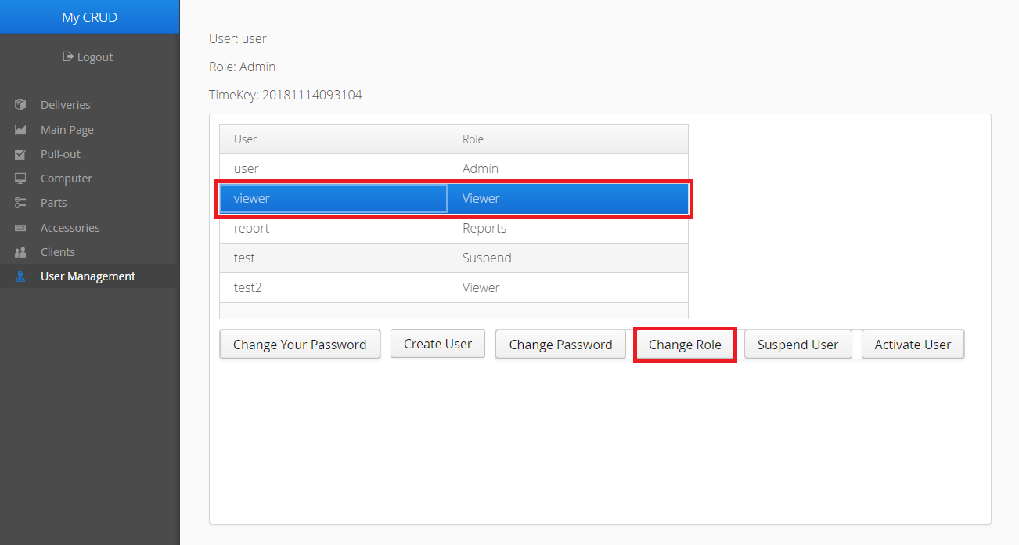

**Step 2**: Select the User’s new role, then click the Go button.

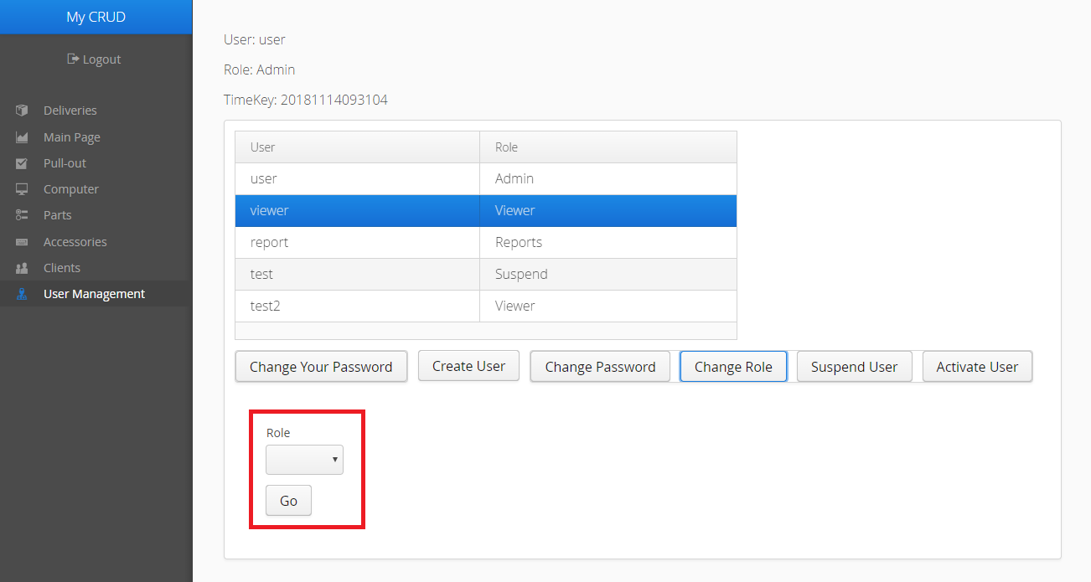

**Step 3**: Click the Yes button in the confirmation dialog window that will appear.



A message displaying the success (or failure) of the operation should appear afterward.